mTerm/Subject | Autumn 1 | Autumn 2 | Spring 1 | Spring 2 | Summer 1 | Summer 2
Character Curriculum | Key text:  Whole School Kindness Day in Family Groups.  Book Name  The Invisible Boy  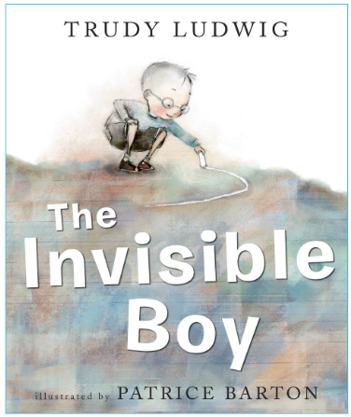  Format:  Fiction  Author:  Trudy Ludwig  School Environment Clean Up  Assembly Overview | Key text:  Whole School Respect Day in Family Groups.  Book Name  Don’t Touch My Hair!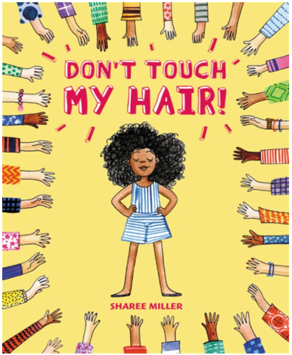  Format:  Fiction  Author:  Sharee Miller  School Environment Clean Up  Assembly Overview | Key text:  Whole School Resilience Day in Family Groups.  Book Name  Storm In a Jar  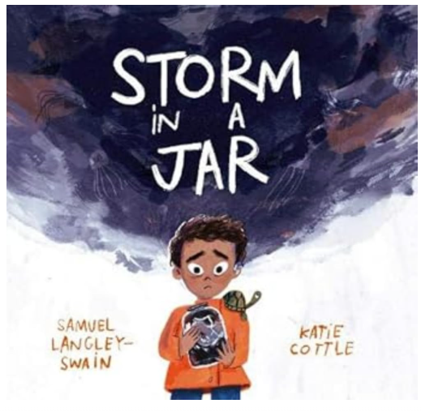  Format:  Children’s literature  Author:  Samuel Langley- Swain  School Environment Clean Up  Assembly Overview | Key text:  Whole School Integrity Day in Family Groups.  Book Name  If Everybody Did  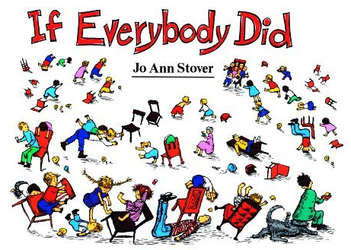  Format:  Fiction  Author:  Jo Ann Stover  School Environment Clean Up  Assembly Overview | Key text:  Whole School Collaboration Day in Family Groups.  Book Name  The One Day House  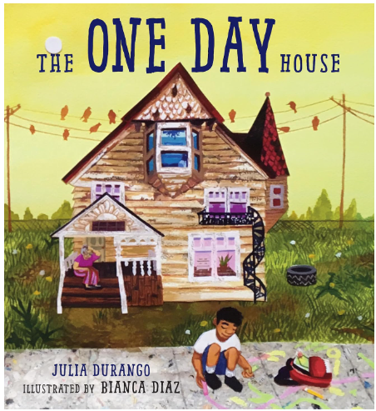  Format:  Fiction  Author:  Julia Durango  School Environment Clean Up  Assembly Overview | Key text:  Whole School Tenacity Day in Family Groups.  Book Name  Emmanuel's Dream- The True Story of Emmanuel Ofosu Yeboah  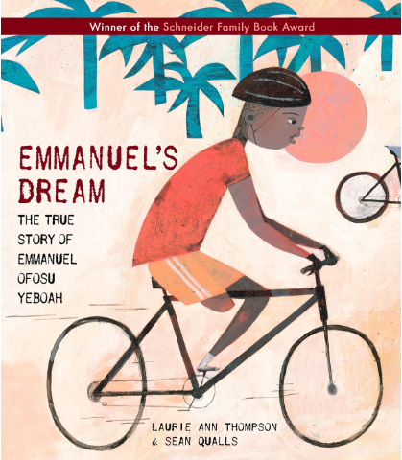  Format:  Biography  Author:  Laurie Ann Thompson  School Environment Clean Up  Assembly Overview
Shine Experiences | Local Library Visit  Norton Priory: History of Runcorn  Visit to a local bakery or supermarket with a nutritionist session | Christmas Service at St Augustine’s  Brindley Theatre | International Slavery Museum (Liverpool)- Slave trade  Merseyside Maritime Museum – excellent context around the transatlantic slave trade.  Catalyst Science Discovery Centre (Widnes) | Delamere Forest Visit & Go Ape  World Book Day  Easter Service at St Augustine’s  World Museum Liverpool – Rainforest & habitats gallery  Blue Planet Aquarium  Nurse or first aid visitor - supports PSHE and healthy living. | Visit from a nurse  World Museum Liverpool  Liverpool Tate Gallery
Reading  (Pathways to read) | Pathways to Read  The Windrush Story by The Literacy Company  Genre- Information | Pathways to Read  The Thames and Tide Club by Katya Balen  Genre- Fiction | Pathways to Read  Blue by Britta Teckentrup  Genre- Fiction: adventure, information | Pathways to Read  Usborne Illustrated Atlas of Britain and Ireland by Struan Reid, Up (film clip, Disney)  Genre- Information | Pathways to Read  Egyptian Cinderella by Shirley Climo, Wonderful Things by The Literacy Company  Genre- Recount, Fiction: historical/ traditional tale | Pathways to Read
Writing  (Pathways to write) | Weeks 1-7:  Pathways:  Sea Surfer by Michael Foreman- recount letter in role  Week 8:  Poetry Writing | Weeks 1-6:  Pathways:  Winter’s Child- Fantasy Story based on a fable  Week 7:  Fiction writing (letter) based on a topic from this term | Week 1-5:  Pathways:  Stone Age Boy- story set in stone age.  Week 6:  Poetry Writing | Week 1-4:  Pathways:  Big Blue Whale – Persuasive leaflet.  Week 5:  Fiction writing – explanation based on a topic from this term. | Week 1-5:  Pathways:  Journey by Arron Becker – Action Story.  Week 6:  Poetry Writing | Week 1-5  Pathways:  Zirraffa Girraffa – Persuasive leaflet.  Week 6:  Persuasive leaflet based on topic from this term
Maths  (MNP) | Maths No Problem
Mastering Number
(NCETM)
Science  (The Heath Trust) | Living things and their habitats  (Year 4 unit) | States of Matter  (Year 4 unit) | Sound  (Year 4 unit) | Animals, including humans  (Year 4 unit) | Electricity  (Year 4 unit)
History  (The Heath Trust) | My History: A History of Runcorn  (Year 4 unit) |  | History of Liverpool- Slave Trade  (Year 4 unit) |  | Benin  (Year 4 unit)
Geography  (The Heath Trust) |  | My Geography: Global Caretakers (Year 4 unit) |  | Rainforests  (Year 4 unit) |  | The Water Cycle  (Year 4 unit)
Art  (Kapow) | Year 4  Painting and Mixed Media: Light and dark  (Revisit: previously taught strand-build progression) |  | Year 4  Drawing: Power Prints  (Revisit: previously taught strand-build progression) |  | Year 4  Sculpture and 3D: Mega Materials
DT  (Kapow) |  | Year 4  Cooking and Nutrition: Adapting a Recipe |  | Year 4  Electrical Systems: Torches |  | Year 4  Mechanical Systems: Slingshot Car  (Revisit: previously taught strand-build progression)
Music  (Charanga)  Highlighted topic to be taught | YR 3 Let your spirit fly  Y4 Mamma Mia | YR 3 Glockenspiel stage 1  Y4 Glockenspiel stage | YR 3 Three little birds  Y4 Stop! | YR 3 The dragon song  Y4 Lean on me | YR 3 Bringing us together  Y4 Black bird | YR 3 Reflect, rewind and replay  Y4 Reflect, rewind and replay
MFL  (French- Kapow) | Year 3/4  Cycle B  Unit 1: This is me |  | Year 3/4  Cycle B  Unit 2: School Days |  | Year 3/4  Cycle B  Unit 3: Birthday Celebrations
RE  (Kapow) | Year 4  Are all religions equal? | Year 4  What makes some texts sacred? | Year 4  Just how important are our beliefs? |  | Year 4  Who was Jesus really?
PSHE  (Jigsaw) | Age 7-8  Being me in my world | Age 7-8  Celebrating difference | Age 7-8  Dreams and goals | Age 7-8  Healthy me | Age 7-8  Relationships | Changing me  (1 day)
Computing  (Kapow)  In cycle A, the children covered three of the five core strands of Kapow Primary’s computing curriculum, cycle B will include the remaining two strands: Creating media and Data handling. |  | Year 4  Online Safety  (1 day) |  | Year 4  Creating Media: Website Design |  | Year 4  Data handling: Investigating weather
PE  (Get set for PE) | Get Set 4 PE

Science | 2 hours per week
History/ Geography | Alternate each term- 1 hour per week
Art/ DT | Alternate each term- 1 hour per week
Music/ MFL | Alternate each term- 1 hour per week
PE | 2 hours per week
Computing/ RE | Alternate each term- 1 hour per week  (Internet safety during autumn term- 1day)
PSHE | 1 hour per week

