Term/Subject | Autumn 1 | Autumn 2 |  | Spring 1 | Spring 2 |  | Summer 1 |  | Summer 2
Character Curriculum | Key text:  Whole School Kindness Day in Family Groups.  Book Name  The Invisible Boy  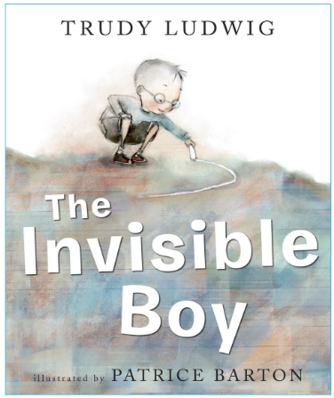  Format:  Fiction  Author:  Trudy Ludwig  School Environment Clean Up  No outsider’s curriculum  Assembly Overview | Key text:  Whole School Respect Day in Family Groups.  Book Name  We Are All Wonders  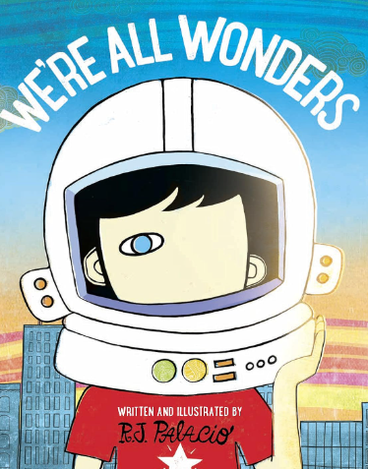  Format:  Fiction  Author:  R.J. Palacio  School Environment Clean Up  No outsider’s curriculum  Assembly Overview |  | Key text:  Whole School Resilience Day in Family Groups.  Book Name  Be Resilient! (Mindful Kids)  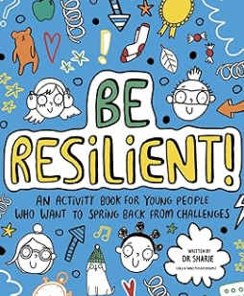  Format:  Self-Care Activity Book  Author:  Dr Sharie Coombes  School Environment Clean Up  No outsider’s curriculum  Assembly Overview | Key text:  Whole School Integrity Day in Family Groups.  Book Name  The Wolf Who Cried Boy: A Fractured Fairy Tales Retelling  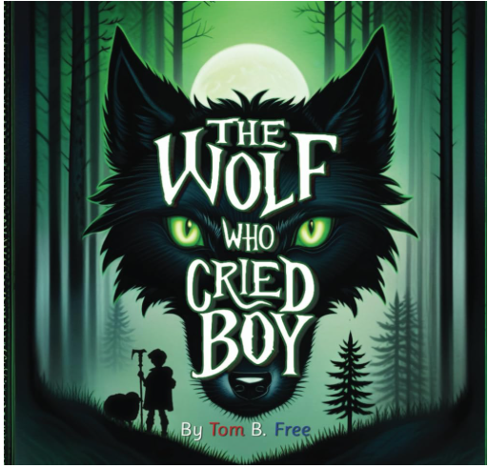  Format:  Fiction  Author:  Tom B Free  School Environment Clean Up  No outsider’s curriculum  Assembly Overview |  | Key text:  Whole School Collaboration Day in Family Groups.  Book Name  The Great Kapok Tree  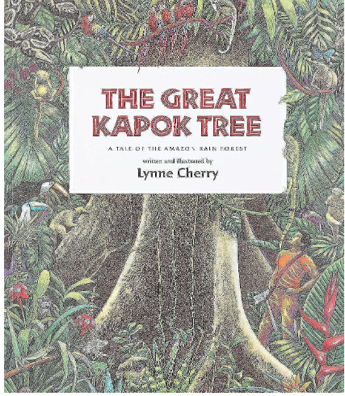  Format:  Fiction  Author:  Lynne Cherry  School Environment Clean Up  No outsider’s curriculum  Assembly Overview |  | Key text:  Whole School Tenacity Day in Family Groups.  Book Name  Emmanuel's Dream- The True Story of Emmanuel Ofosu Yeboah  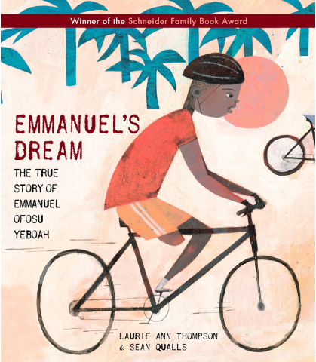  Format:  Biography  Author:  Laurie Ann Thompson  School Environment Clean Up  No outsider’s curriculum  Assembly Overview
Shine Experiences | Local Library Visit  Go Ape Delamere Forest  Chester Dewa Centre | Christmas Service at St Augustine’s  Chill Factor |  | Museum of Liverpool Planetarium  Rock & River Visit Ormskirk | World Book Day  Easter  Service at St Augustine’s  National Football Museum Manchester |  | Manchester Museum of Science and Industry |  | Cinema Trip on the bus  Shakespeare North Playhouse
Reading  (Pathways to read) | Pathways to Read  When we were Warriors by Emma Carroll  Genre- Poetry, Fiction: historical | Pathways to Read  The Place for Me: Stories about the Windrush Generation by Dame Floella Benjamin et al.  Genre- Fiction and non-fiction |  | Pathways to Read  Survivors: Extraordinary Tales from the Wild and Beyond by David Long  Genre- Information, recount | Pathways to Read  You are Awesome by Mathew Syed  Genre- Information |  | Pathways to Read  African Tales: A Barefoot Collection by Gcina Mhlophe  Genre- Fiction: Books from other cultures and traditions |  | Pathways to Read
Writing  (Pathways to write) | Weeks 1-7:  Pathways:  Star of Hope, Star of Fear- Flashback Story  Week 8:  Poetry Writing | Week 1-6:  Pathways: Can we Save the Tiger? Explanation writing  Week 7:  Information text based on topic from this term |  | Week 1-5:  Pathways: Selfish Giant by Oscar Wilde- Narrative.  Week 6:  Poetry Writing | Week 1-4:  Pathways: Jemmy Button – Newspaper.  Week 5:  Narrative linked to topic from this term. |  | Week 1-5:  Pathways: Manfish – Biography  Week 6:  Poetry Writing |  | Week 1-6  Pathways: 4 weeks – text linked to transition
Maths  (MNP) | Maths No Problem
Science  (The Heath Trust) | Electricity  (Year 6 unit) | Light  (Year 6 unit) |  | Living Things and Their Habitats  (Year 6 unit) | Evolution and Inheritance  (Year 6 unit) |  | Animals Including Humans  (Year 6 unit)
History  (The Heath Trust) | World War 2  (Year 6 unit) |  |  | Ancient Greece  (Year 6 unit) |  |  | Mayans  (Year 6 unit)
Geography  (The Heath Trust) |  | My Geography:  Looking after our landscape  (Year 6 unit) |  |  | Mountains and Rivers  (Year 6 unit) |  |  |  | Extreme Earth  (Year 6 unit)
Art  (Kapow) | Year 6  Sculpture and 3D: Making Memories |  |  | Year 6  Painting and mixed media: Artist study  (Revisit: previously taught strand-build progression) |  |  | Year 6  Drawing: Make my voice heard  (Revisit: previously taught strand-build progression)
DT  (Kapow) |  | Year 6  Textiles- Waistcoats |  |  | Year 6  Electrical Systems- Steady hand game |  |  |  | Year 6  Structures- Playgrounds  (Revisit: previously taught strand-build progression)
Music  (Charanga)  Highlighted topic to be taught | YR 5 Livin’ on a prayer  YR 6 Happy | YR 5 Classroom jazz 1  YR 6 Classroom jazz 2 |  | YR 5 Make you feel my love  YR 6 A new year carol | YR 5 The fresh prince of Bel-Air  YR 6 You’ve got A friend |  | YR 5 Dancing in the street  YR 6 Music and me |  | YR 5 Reflect, rewind and replay  YR 6 Reflect, rewind and replay
MFL  (French- Kapow) | Year 5/6  Cycle A  Portraits- Describing in French |  |  | Year 5/6  Cycle A  Meet my French family |  |  | Year 5/6  Cycle A  Clothes- Getting dressed in France
RE  (Kapow) | Year 6  Why does religion look different around the world? (part 1) | Year 6  Why does religion look different around the world? (part 2) |  | Year 6  Why is it better to be there in person? |  |  | Year 6  Why is there suffering? (part 1)
PSHE  (Jigsaw) | Age 9-10  Being me in my world | Age 9-10  Celebrating Difference |  | Age 9-10  Dreams and goals | Age 9-10  Healthy me |  | Age 9-10  Relationships |  | Changing me  (1 day)
Computing  (Kapow)  In cycle A, the children covered three of the five core strands of Kapow Primary’s computing curriculum, cycle B will include the remaining two strands: Computing systems and networks and Data handling. |  | Year 6  Online Safety  (1 day) |  |  | Year 6  Computing systems and networks: Exploring AI |  |  | Year 6  Data Handling: Big Data 1
PE  (Get set for PE) | Get Set 4 PE

Science | 2 hours per week
History/ Geography | Alternate each term- 1 hour per week
Art/ DT | Alternate each term- 1 hour per week
Music/ MFL | Alternate each term- 1 hour per week
PE | 2 hours per week
Computing/ RE | Alternate each term- 1 hour per week  (Internet safety during autumn term- 1day)
PSHE | 1 hour per week

