Term/Subject | Autumn 1 |  | Autumn 2 | Spring 1 | Spring 2 | Summer 1 | Summer 2
Character Curriculum | Key text:  Whole School Kindness Day in Family Groups.  Book Name  Being me  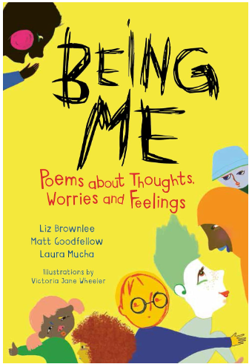  Format:  Poetry  Author:  Liz Brownlee, Matt Goodfellow & Laura Mucha  School Environment Clean Up  No Outsiders Curriculum  Assembly Overview |  | Key text:  Whole School Respect Day in Family Groups.  Book Name  Lailah’s Lunchbox  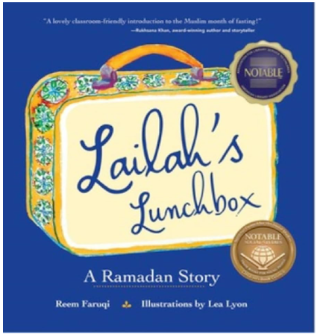  Format: Religious Fiction  Author:  Reem Faruqi  School Environment Clean Up  No Outsiders Curriculum  Assembly Overview | Key text:  Whole School Resilience Day in Family Groups.  Book Name  A better day: Your positive mental health handbook  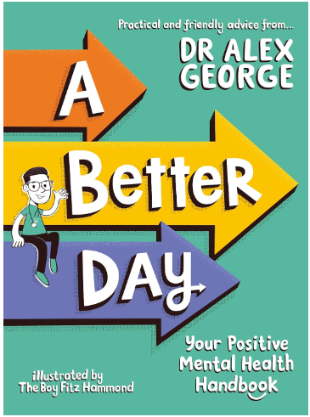  Format:  Non-fiction  Author:  Dr Alex George  School Environment Clean Up  No Outsiders Curriculum  Assembly Overview | Key text:  Whole School Integrity Day in Family Groups.  Book Name  The True Story of the Three Little Pigs  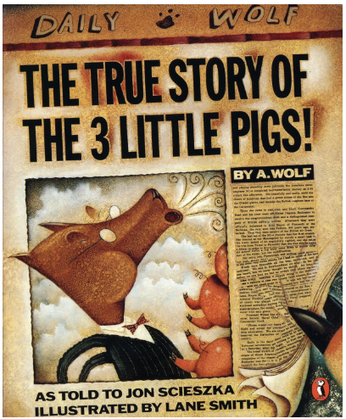  Format:  newspaper style  Author:  Jon Scieszka  School Environment Clean Up  No Outsiders Curriculum  Assembly Overview | Key text:  Whole School Collaboration Day in Family Groups.  Book Name  Cinnamon  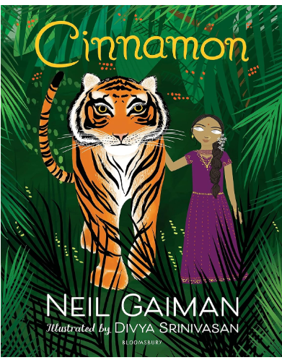  Format:  Fable  Author:  Neil Gaiman  School Environment Clean Up  No Outsiders Curriculum  Assembly Overview | Key text:  Whole School Tenacity Day in Family Groups.  Book Name  Break the Mould: How to Take Your Place in the World  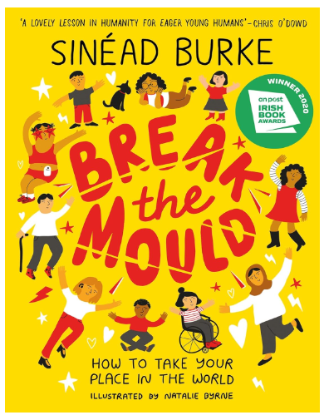  Format:  Non-fiction  Author:  Sinéad Burke  School Environment Clean Up  No Outsiders Curriculum  Assembly Overview
Shine Experiences | Local Library Visit  Go Ape Delamere Forest  Chester Dewa Centre |  | Christmas Service at St Augustine’s  Chill Factor | Museum of Liverpool Planetarium  Rock & River Visit Ormskirk | World Book Day  Easter  Service at St Augustine’s  National Football Museum Manchester | Manchester Museum of Science and Industry | Cinema Trip on the bus  Shakespeare North Playhouse
Reading  (Pathways to read) | Goodnight Stories for Rebel Girls by Eleni Favilli & Francesca Cavallo |  | Hansel & Gretel by Neil Gaiman and Lorenzo Mattotti | Odd and the Frost Giants by Neil Gaiman | Exploring Space | Pollution: A Look Behind the Scenes | Bold and Brave Women from Shakespeare  By The Shakespeare Birth Trust
Writing  (Pathways to write) | Pathways:  Queen of the Falls by Chris Van Allsburg  Recount- diary  Poetry Writing:  The Song of Hiawatha |  | Pathways:  The Lost Happy Endings by Carol Ann Duffy  Fiction- Traditional Tale  Recount revisit based on topic from this term | Pathways:  Arthur and the Golden Rope by Joe Todd-Stanton  Fiction- Myth  Poetry Writing: Vikings, Kennings & Spells | Pathways:  The Darkest Dark by Chris Hadfield  Recount – biography  Narrative linked to topic from this term. | Pathways:  The Paperbag Prince Colin Thompson  Persuasive poster  Poetry Writing: Animals of Africa | Pathways:  Radiand Child by Javaka Steptoe  Information text
Maths  (MNP) | Maths No Problem
Science  (The Heath Trust) | Properties and Changes of Materials  (Year 5 unit) |  | Properties and Changes of Materials  (Year 5 unit) | Earth and Space  (Year 5 unit) | Forces and Movement  (Year 5 unit) | Living Things and Their Habitats  (Year 5 unit) | Animals Including Humans  (Year 5 unit)
History  (The Heath Trust) | Romans  (Year 5 unit) |  |  | Anglo Saxons  (Year 5 unit) |  | Vikings  (Year 5 unit)
Geography  (The Heath Trust) |  | My Geography:  Trade Across the Globe  (Year 5 unit) |  |  | Biomes  (Year 5 unit) |  |  | Brazil  (Year 5 unit)
Art  (Kapow) | Year 5  Drawing: I need space |  |  | Year 5  Painting and mixed media: Portraits |  | Year 5  Craft and design: Architecture
DT  (Kapow) |  |  | Year 5  Structure- bridges |  | Year 5  Mechanical System- Pop up Book |  | Year 5  Cooking and Nutrition- Developing a recipe
Music  (Charanga)  Highlighted topic to be taught | Year 5 Livin’ on a prayer  Year 6 Happy |  | Year 5 Classroom jazz 1  Year 6 Classroom jazz 2 | Year 5 Make you feel my love  Year 6 A new year carol | Year 5 The fresh prince of Bel-Air  Year 6 You’ve got A friend | Year 5 Dancing in the street  Year 6 Music and me | Year 5 Reflect, rewind and replay  Year 6 Reflect, rewind and replay
MFL  (French- Kapow) | Year 5/6  Cycle B  French transport |  |  | Year 5/6  Cycle B  In my French house |  | Year 5/6  Cycle B  French music celebrations
RE  (Kapow) | Year 5  Why do people have to stand up for what they believe in? |  |  | Year 5  Why doesn’t Christianity always look the same? |  | Year 5  What happens when we die? (Part 1)
PSHE  (Jigsaw) | Age 10-11  Being me in my world |  | Age 10-11  Celebrating Difference | Age 10-11  Dreams and goals | Age 10-11  Healthy me | Age 10-11  Relationships | Changing me  (1 day)
Computing  (Kapow) |  |  | Year 5  Online Safety |  | Year 5  Programming 1: Music |  | Year 5  Creating media: Stop motion animation
PE  (Get set for PE) | Get Set 4 PE

Science | 2 hours per week
History/ Geography | Alternate each term- 1 hour per week
Art/ DT | Alternate each term- 1 hour per week
Music/ MFL | Alternate each term- 1 hour per week
PE | 2 hours per week
Computing/ RE | Alternate each term- 1 hour per week
PSHE | 1 hour per week

