Term/Subject | Autumn 1 |  | Autumn 2 | Spring 1 | Spring 2 | Summer 1 | Summer 2
Character Curriculum | Key text:  Whole School Kindness Day in Family Groups.  Book Name  Kind  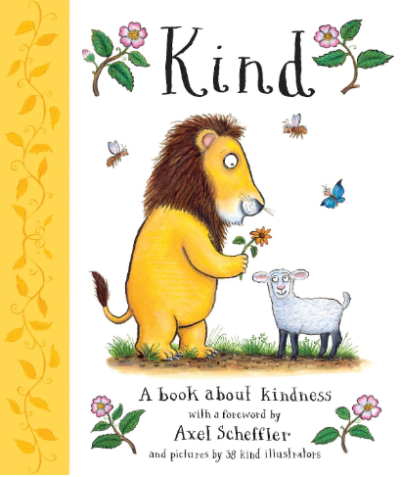  Format:  Fiction  Author:  Alison Green & 38 illustrators  School Environment Clean Up  Assembly Overview |  | Key text:  Whole School Respect Day in Family Groups.  Book Name  Do Unto Otters  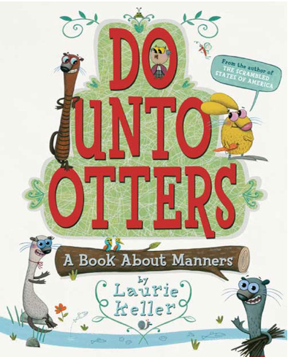  Format:  Fiction  Author:  Laurie Keller  School Environment Clean Up  Assembly Overview | Key text:  Whole School Resilience Day in Family Groups.  Book Name  Ruby's Worry  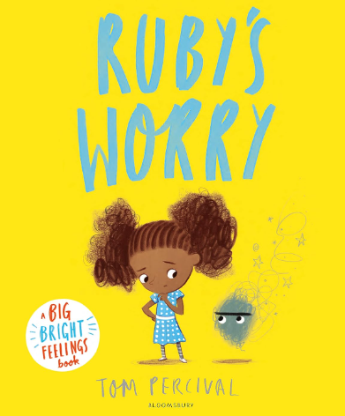  Format:  Fiction  Author:  Tom Percival  School Environment Clean Up  Assembly Overview | Key text:  Whole School Integrity Day in Family Groups.  Book Name  What If Everybody  Did That?  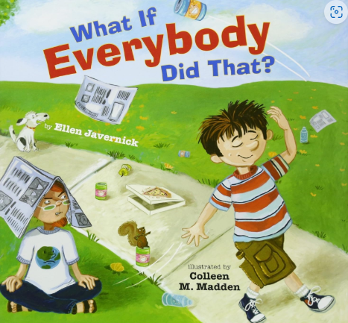  Format:  Fiction  Author:  Ellen Javernick  School Environment Clean Up  Assembly Overview | Key text:  Whole School Collaboration Day in Family Groups.  Book Name  Swimmy  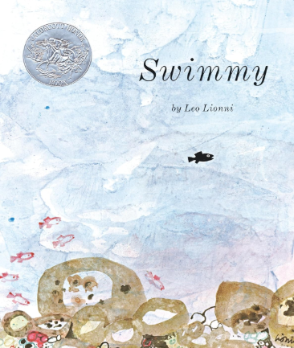  Format:  Fiction  Author:  Leo Lionni  School Environment Clean Up  Assembly Overview | Key text:  Whole School Tenacity Day in Family Groups.  Book Name  The Most Magnificent Thing  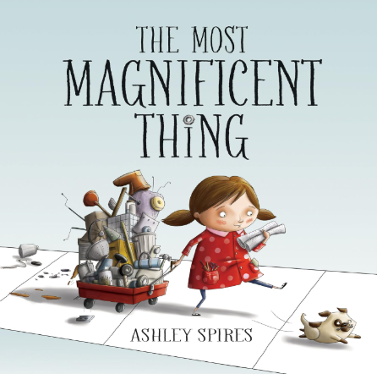  Format:  Fiction  Author:  Ashley Spires  School Environment Clean Up  Assembly Overview
Shine Experiences | Local Library Visit  Martin Mere  Catalyst Science Discovery Centre (Widnes) |  | Walk Around the Local Environment  Visitor: PCSO or emergency services  Christmas Service at St Augustine’s | Delamere Forest  Chester Cathedral or Mosque Visit  Brindley Theatre | People who help us: Visit from PCSO  World Book Day  Easter Service at St Augustines  Lunt Meadows Nature Reserve; Liverpool | Seaside visit  Visitor: Faith leader or parent  Apple Jacks Adventure Farm (Warrington) | Walton Gardens Go Ape  Titanic workshop: Maritime Museum
Reading  (Pathways to read) | Read, Write Inc |  | Read, Write Inc | Read, Write Inc  Pathways to Read | Read, Write Inc  Pathways to Read | Read, Write Inc  Pathways to Read | Read, Write Inc  Pathways to Read
Writing  (Pathways to write) | Weeks 1-7:  Pathways:  Troll Swap – Story with characters  Week 8:  Poetry writing |  | Weeks 1-6 :  The Owl Who was Afraid of the Dark- Non chronological Report  Week 7:  Fiction writing revisit based on a topic from this term | Weeks 1-5:  Dragon Machine- Story with Adventure  Week 6:  Poetry writing | Weeks 1-4:  Major Glad, Major Dizzy- Diary entry from the point of view of a Toy  Week 5:  Fiction writing revisit (non chronological report) based on a topic of this term. | Weeks 1-5:  The Last Wolf -Persuasive Letter  Week 6:  Poetry writing | Weeks 1-5:  Grandad’s Secret Giant- fiction story with a moral focus  Week 6:  Fiction writing (letter) based on a topic from this term.
Maths  (MNP) | Maths No Problem
Mastering Number
(NCETM)
Science  (The Heath Trust) | Everyday Materials  (Year 1 unit) |  | Uses of everyday materials  (Year 2 unit) | Living things and their habitats  (Year 2 unit) |  | Exploring Scientists  (Year 1/2 appropriate)
History  (The Heath Trust) | My history: Changes in Britain-  Victorian History  (Year 2 unit) |  |  | Famous people travel and exploration  (Year 2 unit) |  | The Titanic  (Year 2 unit)
Geography  (The Heath Trust) |  |  | My Geography:  Let’s Go Global (Year 2 unit) |  | Kenya  (Year 2 unit) |  | Hot and cold around the World (Year 2 unit)
Art  (Kapow) | Year 1  Drawing: Make your mark |  |  | Year 2  Drawing: Tell a story |  | Year 2  Painting and mixed media: Life in colour  (Revisit: previously taught strand-build progression)
DT  (Kapow) |  |  | Year 2  Textiles: pouches |  | Year 2  Cooking and Nutrition: Balanced Diet  (Revisit: previously taught strand-build progression) |  | Year 2  Mechanisms: Making a moving monster  (Revisit: previously taught strand-build progression)
Music  (Charanga)  Highlighted topic to be taught | YR 1 Hey you  YR 2 Hands, feet, heart |  | YR 1 Rhythm in the way we walk and banana rap  YR 2 Ho Ho Ho | YR 1 In the groove  YR 2 I want to play in a band | YR 1 Round and round  YR 2 Zoo time | YR 1 Your imagination  YR 2 Friendship song | YR 1 Reflect, rewind and replay  YR 2 Reflect, rewind and replay
RE  (Kapow) | Year 2  Why do we need to give thanks? |  | Year 2  Why do candles mean to people? | Year 2  How do we know some people feel a special connection to a god? |  | Year 2  What is a prophet?
PSHE  (Jigsaw) | Age 5-6  Being me in my world |  | Age 5-6  Celebrating Difference | Age 5-6  Dreams and goals | Age 5-6  Healthy me | Age 5-6  Relationships | Changing me  (1 day)
Computing  (Kapow)  In cycle A, the children covered three of the five core strands of Kapow Primary’s computing curriculum, cycle B will include the remaining two strands: Creating media and Data handling. |  | Year 2  Online Safety  (1 day) |  |  | Year 2  Creating media: Stop Motion-Using desktops/ laptops |  | Year 2  Data handling: International Space Station
PE  (Get set for PE) | Get Set 4 PE

Science | 2 hours per week
History/ Geography | Alternate each term- 1 hour per week
Art/ DT | Alternate each term- 1 hour per week
Music/ MFL | Alternate each term- 1 hour per week
PE | 2 hours per week
Computing/ RE | Alternate each term- 1 hour per week  (Internet safety during autumn term- 1day)
PSHE | 1 hour per week

