Term/Subject | Autumn 1 | Autumn 2 | Spring 1 | Spring 2 | Summer 1 | Summer 2
Character Curriculum | Key text:  Whole School Kindness Day in Family Groups.  Book Name  Being me  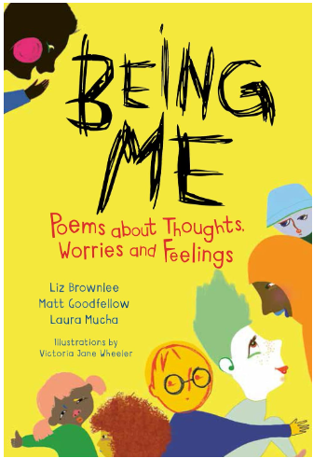  Format:  Poetry  Author:  Liz Brownlee, Matt Goodfellow & Laura Mucha  School Environment Clean Up  Assembly Overview | Key text:  Whole School Respect Day in Family Groups.  Book Name  My mouth is a volcano  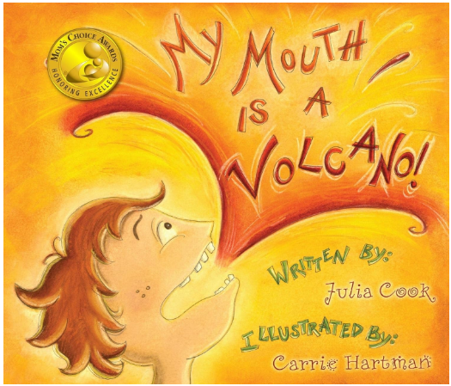  Format:  Picture book  Author:  Julia Cook  School Environment Clean Up  Assembly Overview | Key text:  Whole School Resilience Day in Family Groups.  Book Name  After the Fall  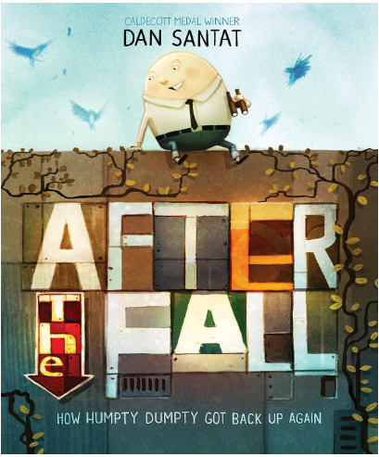  Format:  Graphic Novel  Author:  Dan Santat  School Environment Clean Up  Assembly Overview | Key text:  Whole School Integrity Day in Family Groups.  Book Name  The Magic Paintbrush  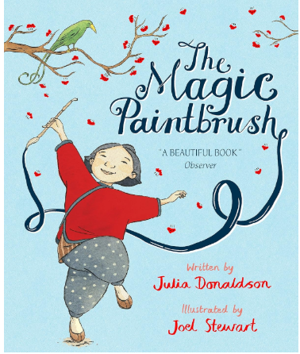  Format:  Picture book  Author:  Julia Donaldson  School Environment Clean Up  Assembly Overview | Key text:  Whole School Collaboration Day in Family Groups.  Book Name  What We’ll Build  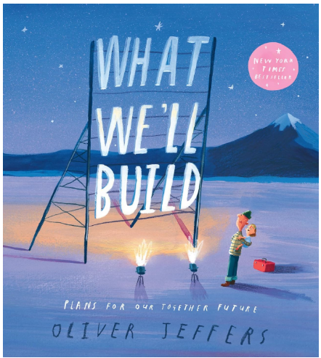  Format: Picture Book  Author: Oliver Jeffers  School Environment Clean Up  Assembly Overview | Key text:  Whole School Tenacity Day in Family Groups.  Book Name  All Sorts  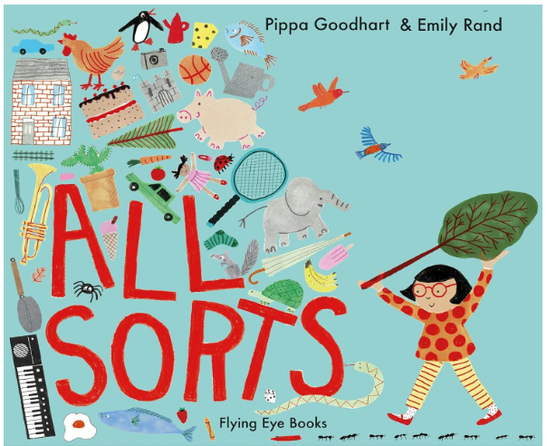  Format: Picture Book  Author: Pippa Goodhart and Emily Rand  School Environment Clean Up  Assembly Overview
Shine Experiences | Local Library Visit  Martin Mere | Walk Around the Local Environment  Christmas Service at St Augustine’s | Museum of Liverpool: Then and Now Toys Workshop  Warrington Museum and Art Gallery: KS1 Toys in the past workshop | People who help us: Visit from PCSO  World Book Day  Easter Service at St Augustines  Lunt Meadows Nature Reserve; Liverpool | Seaside visit | Walton Gardens- Go Ape  Visit from a grandparent to support History topic- holidays in the Past
Reading  (Pathways to read) | Read, Write Inc | Read, Write Inc | Read, Write Inc  Pathways to Reading | Read, Write Inc  Pathways to Reading | Read, Write Inc  Pathways to Reading | Read, Write Inc  Pathways to Reading
Writing  (Pathways to write) | Pathways:  Lost and Found by Oliver Jeffers  Adventure Story Writing  Poetry writing: Sea Songs | Pathways:  Nibbles the Book Monster By Emma Yarlett  Recount- diary writing  Fiction writing revisit based on a topic from this term | Pathways:  The Lion Inside by Rachel Bright and Jim Field  Fiction  Poetry writing: From a Railway Carriage | Pathways:  The Curious Case of the Missing Mammoth by Ellie Hattie  Adventure Story  Diary writing revisit based on a topic of this term. | Pathways:  Toys in Space by Mini Grey  Fantasy Story  Poetry writing: I Spun a Star | Pathways:  Goldilocks and Just the One Bear by Leigh Hodkinson  Story writing based on a topic from this term.
Maths  (MNP) | Maths No Problem
Mastering Number
(NCETM)
Science  (The Heath Trust) | Seasons and Weather  (Year 1 unit) | Animals Including Humans  (Year 1 unit) | Animals Including Humans  (Year 2 unit) | Plants  (Year 1 unit) | Plants  (Year 2 unit)
History  (The Heath Trust) | My History: People in my Family  (Year 1 unit) |  | Toys Through Time  (Year 1 unit) |  | Holidays in the Past  (Year 1 unit)
Geography  (The Heath Trust) |  | My Geography:  The Geography of Bridgewater Park Primary  (Year 1 unit) |  | Where Are We? UK Geography  (Year 1 unit) |  |  | Why Different Weather?  (Year 1 unit)
Art  (Kapow) | Year 1  Craft and design: Woven wonders |  | Year 1  Sculpture and 3D: Paper play |  | Year 1  Painting and mixed media: Colour splash
DT  (Kapow) |  | Year 1  Cooking & Nutrition: Smoothies |  | Year 1  Structures: Constructing a Windmill |  | Year 1  Mechanisms: Making a moving story book
Music  (Charanga)  Highlighted topic to be taught | Year 1 Hey you  Year 2 Hands, feet, heart | Year 1 Rhythm in the way we walk and banana rap  Year 2 Ho Ho Ho | Year 1 In the groove  Year 2 I want to play in a band | Year 1 Round and round  Year 2 Zoo time | Year 1 Your imagination  Year 2 Friendship song | Year 1 Reflect, rewind and replay  Year 2 Reflect, rewind and replay
RE  (Kapow) | Year 1  How did the World Begin? |  | Year 1  What is God’s job? |  | Year 1  Why should we care for others?
PSHE  (Jigsaw) | Age 6-7  Being me in my world | Age 6-7  Celebrating Difference | Age 6-7  Dreams and goals | Age 6-7  Healthy me | Age 6-7  Relationships | Changing me  (1 day)
Computing  (Kapow) |  | Year 1  Online Safety |  | Year 1  Computing systems and networks: Improving mouse skills |  | Year 1  Programming 1: Algorithms unplugged
PE  (Get set for PE) | Get Set 4 PE

Science | 2 hours per week
History/ Geography | Alternate each term- 1 hour per week
Art/ DT | Alternate each term- 1 hour per week
Music/ MFL | Alternate each term- 1 hour per week
PE | 2 hours per week
Computing/ RE | Alternate each term- 1 hour per week
PSHE | 1 hour per week

