Term/Subject | Autumn 1 | Autumn 2 | Spring 1 | Spring 2 | Summer 1 | Summer 2
Character Curriculum | Key text:  Whole School Kindness Day in Family Groups.  Book Name  Being me  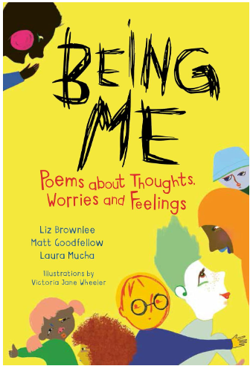  Format:  Poetry  Author:  Liz Brownlee, Matt Goodfellow & Laura Mucha  School Environment Clean Up  Assembly Overview | Key text:  Whole School Respect Day in Family Groups.  Book Name  Lailah’s Lunchbox  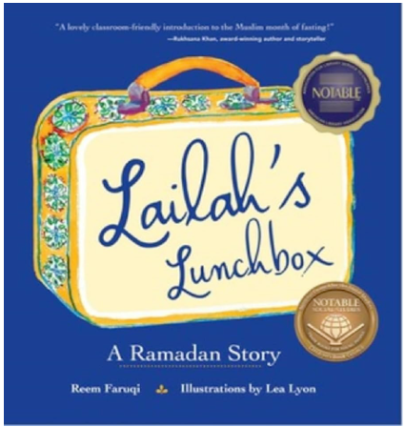  Format: Religious Fiction  Author:  Reem Faruqi  School Environment Clean Up  Assembly Overview | Key text:  Whole School Resilience Day in Family Groups.  Book Name  A better day: Your positive mental health handbook  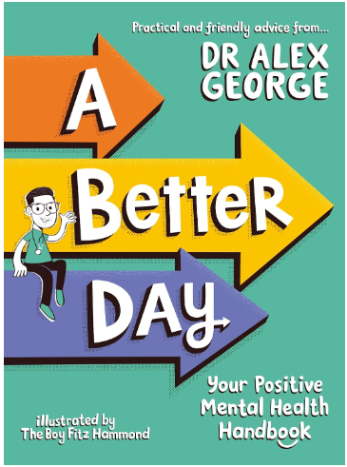  Format:  Non-fiction  Author:  Dr Alex George  School Environment Clean Up  Assembly Overview | Key text:  Whole School Integrity Day in Family Groups.  Book Name  The True Story of the Three Little Pigs  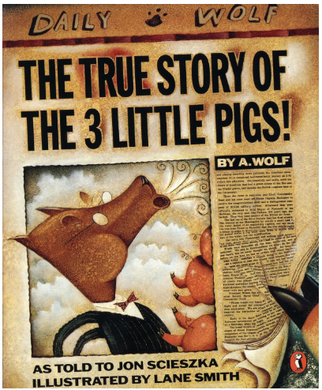  Format:  newspaper style  Author:  Jon Scieszka  School Environment Clean Up  Assembly Overview | Key text:  Whole School Collaboration Day in Family Groups.  Book Name  Cinnamon  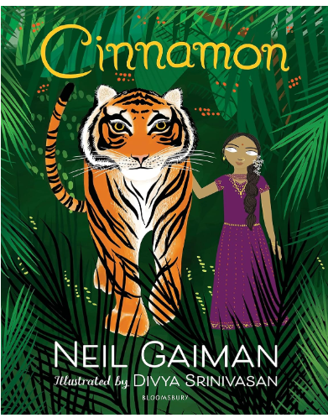  Format:  Fable  Author:  Neil Gaiman  School Environment Clean Up  Assembly Overview | Key text:  Whole School Tenacity Day in Family Groups.  Book Name  Break the Mould: How to Take Your Place in the World  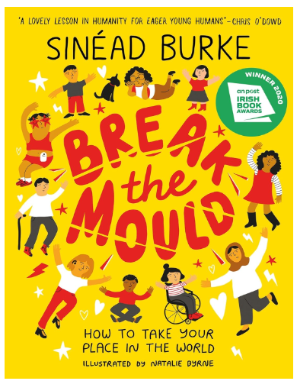  Format:  Non-fiction  Author:  Sinéad Burke  School Environment Clean Up  Assembly Overview
Shine Experiences | Local Library Visit  Norton Priory: History of Runcorn | Christmas Service at St Augustine’s | Liverpool World Museum | Delamere Forest Visit & Go Ape  World Book Day  Easter Service at St Augustine’s | Visit from a nurse
Reading  (Pathways to read) | The Sea Book by Charlotte Milner | Ice Palace by Robert Swindells | The Iron Man by Ted Hughes | The Morning I met a Whale by Michael Morpurgo | Amazing Rivers by Julie Vosburgh Agone | Exploring Shakespeare’s London
Writing  (Pathways to write) | Pathways:  Gorilla by Anthony Brown  Recount writing  Poetry Writing: The Shell by John Foster | Pathways:  Leon and the Place in Between  By Graham Baker Smith and Angela McAlister  Recount revisit based on a topic from this term | Pathways:  Escape from Pompeii by Christina Balit  Poetry Writing: The River’s Tale by Rudyard Kipling | Pathways: Koji’s Island  Fiction writing – explanation based on a topic from this term. | Pathways:  Where the Forest Meets the Sea by Jeanie Baker  Poetry Writing: I Saw a Peacock | Pathways:  Blue John by Berlie Doherty  Fiction writing based on topic from this term.
Maths  (MNP) | Maths No Problem
Mastering Number
(NCETM)
Science  (The Heath Trust) | Forces and Magnets  (Year 3 unit) | Animals Including Humans  (Year 3 unit) | Light  (Year 3 unit) | Plants  (Year 3 unit) | Rocks  (Year 3 unit)
History  (The Heath Trust) | Stone Age  (Year 3 unit) |  | Bronze and Iron Age  (Year 3 unit) |  | Ancient Egypt  (Year 3 unit)
Geography  (The Heath Trust) |  | My Geography:  Where am I in Europe?  (Year 3 unit) |  | Urban and Rural UK (Year 3 unit) |  | Naples  (Year 3 unit)
Art  (Kapow) | Year 3  Painting and mixed media: Prehistoric painting |  | Year 3  Drawing: Growing artists |  | Year 3  Craft and design: Ancient Egyptian scrolls
DT  (Kapow) |  | Year 3  Mechanical Systems: Pneumatic systems |  | Year 3  Textiles- Cross Stitch and Applique |  | Year 3  Structures- Constructing a Castle
Music  (Charanga)  Highlighted topic to be taught | Year 3 Let your spirit fly  Year 4 Mamma Mia | Year 3 Glockenspiel stage 1  Year 4 Glockenspiel stage | Year 3 Three little birds  Year 4 Stop! | Year 3 The dragon song  Year 4 Lean on me | Year 3 Bringing us together  Year 4 Black bird | Year 3 Reflect, rewind and replay  Year 4 Reflect, rewind and replay
MFL  (French- Kapow) | Year 3/4  Cycle A  Unit 1: French greetings with puppets |  | Year 3/4  Cycle A  Unit 2: French adjectives of colour, size and shape |  | Year 3/4  Cycle A  Unit 3: French playground games- numbers and age
RE  (Kapow) | Year 3  What makes us human? |  | Year 3  Where do our morals come from? |  | Year 3  Why is water symbolic?
PSHE  (Jigsaw) | Age 8-9  Being me in my world | Age 8-9  Celebrating difference | Age 8-9  Dreams and goals | Age 8-9  Healthy me | Age 8-9  Relationships | Changing me  (1 day)
Computing  (Kapow) |  | Year 3  Online Safety |  | Year 3  Computing systems and networks 1: Networks |  | Year 3  Programming: Scratch
PE  (Get set for PE) | Get Set 4 PE

Science | 2 hours per week
History/ Geography | Alternate each term- 1 hour per week
Art/ DT | Alternate each term- 1 hour per week
Music/ MFL | Alternate each term- 1 hour per week
PE | 2 hours per week
Computing/ RE | Alternate each term- 1 hour per week
PSHE | 1 hour per week

