Cycle B
Year 1/2
Growing Up Great Curriculum
Term/Subject | Autumn 1 | Autumn 2 | Spring 1 | Spring 2 | Summer 1 | Summer 2
Character Curriculum | Key text:  Whole School Kindness Day in Family Groups.  Book Name  Kind  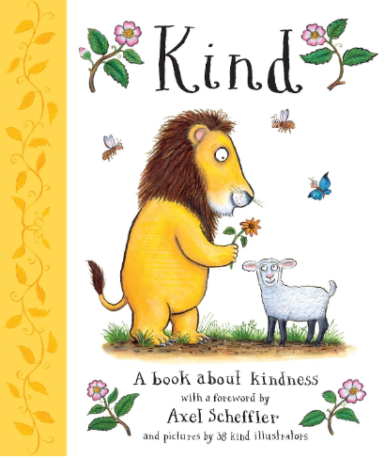  Format:  Fiction  Author:  Alison Green & 38 illustrators | Key text:  Whole School Respect Day in Family Groups.  Book Name  Do Unto Otters  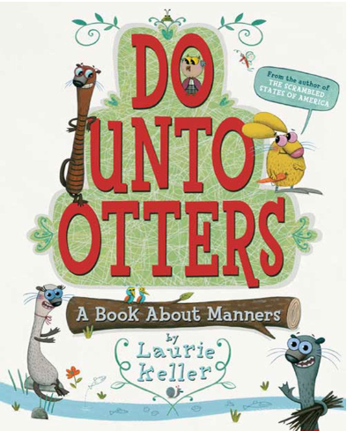  Format:  Fiction  Author:  Laurie KelleFormat | Key text:  Whole School Resilience Day in Family Groups.  Book Name  Ruby's Worry  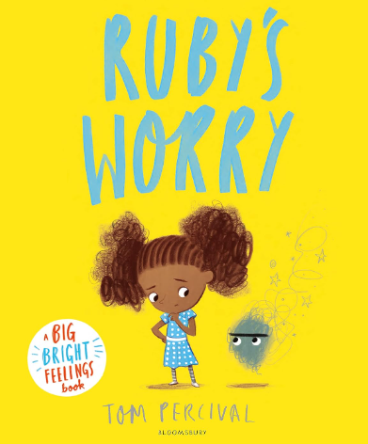  Format:  Fiction  Author:  Tom Percival | Key text:  Whole School Integrity Day in Family Groups.  Book Name  What If Everybody  Did That?  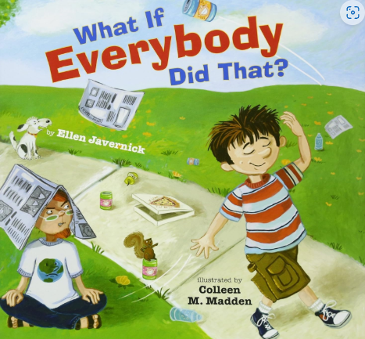  Format:  Fiction  Author:  Ellen Javernick | Key text:  Whole School Collaboration Day in Family Groups.  Book Name  Swimmy  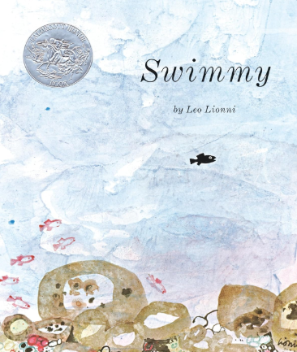  Format:  Fiction  Author:  Leo Lionni | Key text:  Whole School Tenacity Day in Family Groups.  Book Name  The Most Magnificent Thing  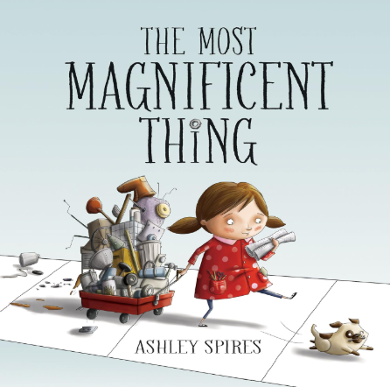  Format:  Fiction  Author:  Ashley Spires
Cycle B
Year 3/4
Growing Up Great Curriculum
Term/Subject | Autumn 1 | Autumn 2 | Spring 1 | Spring 2 | Summer 1 | Summer 2
Character Curriculum | Key text:  Whole School Kindness Day in Family Groups.  Book Name  The Invisible Boy  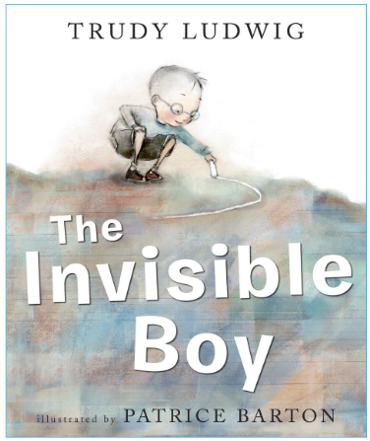  Format:  Fiction  Author:  Trudy Ludwig | Key text:  Whole School Respect Day in Family Groups.  Book Name  Don’t Touch My Hair!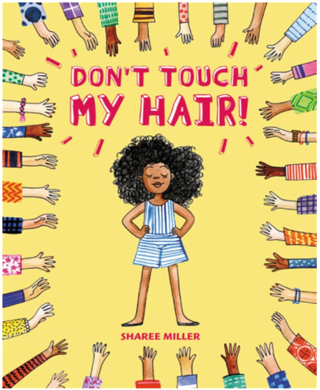  Format:  Fiction  Author:  Sharee Miller | Key text:  Whole School Resilience Day in Family Groups.  Book Name  Storm In a Jar  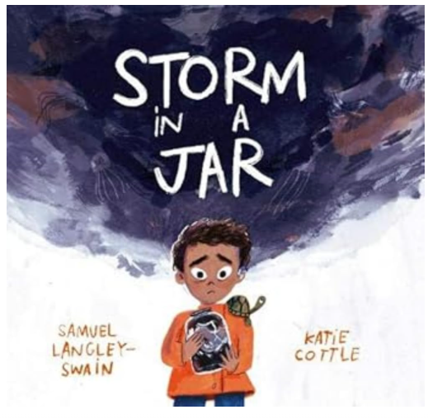  Format:  Children’s literature  Author:  Samuel Langley- Swain | Key text:  Whole School Integrity Day in Family Groups.  Book Name  If Everybody Did  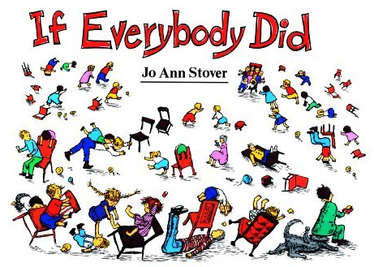  Format:  Fiction  Author:  Jo Ann Stover | Key text:  Whole School Collaboration Day in Family Groups.  Book Name  The One Day House  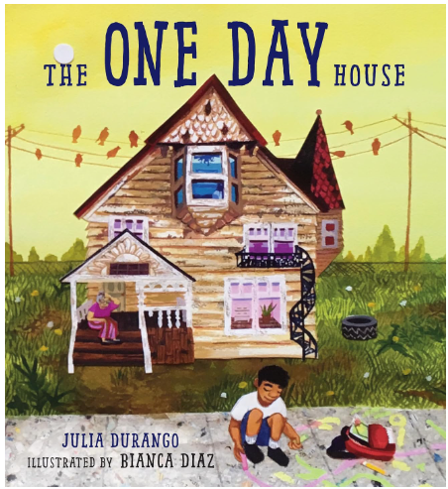  Format:  Fiction  Author:  Julia Durango | Key text:  Whole School Tenacity Day in Family Groups.  Book Name  Emmanuel's Dream- The True Story of Emmanuel Ofosu Yeboah  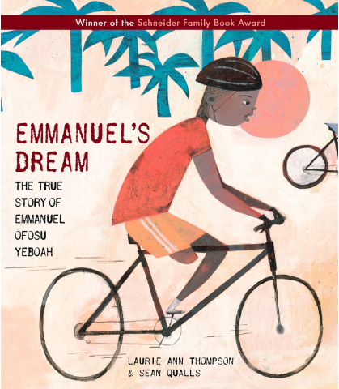  Format:  Biography  Author:  Laurie Ann Thompson
Cycle B
Year 5/6
Growing Up Great Curriculum
Term/Subject | Autumn 1 | Autumn 2 | Spring 1 | Spring 2 | Summer 1 | Summer 2
Character Curriculum | Key text:  Whole School Kindness Day in Family Groups.  Book Name  The Invisible Boy  Format:  Fiction  Author:  Trudy Ludwig | Key text:  Whole School Respect Day in Family Groups.  Book Name  We Are All Wonders  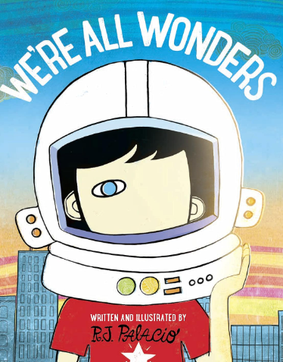  Format:  Fiction  Author:  R.J. Palacio | Key text:  Whole School Resilience Day in Family Groups.  Book Name  Be Resilient! (Mindful Kids)  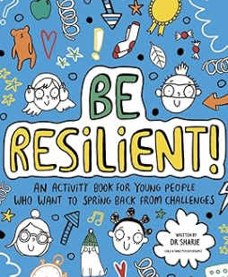  Format:  Self-Care Activity Book  Author:  Dr Sharie Coombes | Key text:  Whole School Integrity Day in Family Groups.  Book Name  The Wolf Who Cried Boy: A Fractured Fairy Tales Retelling  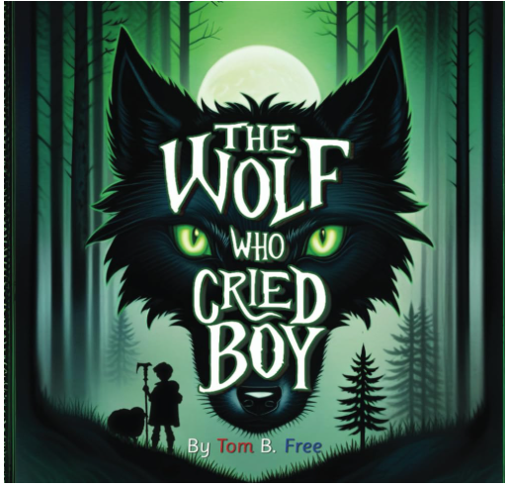  Format:  Fiction  Author:  Tom B Free | Key text:  Whole School Collaboration Day in Family Groups.  Book Name  The Great Kapok Tree  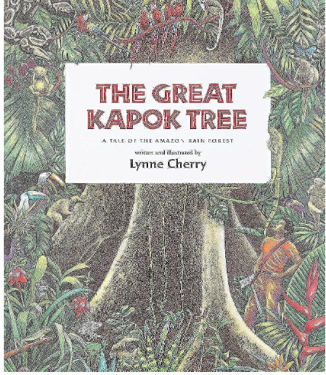  Format:  Fiction  Author:  Lynne Cherry | Key text:  Whole School Tenacity Day in Family Groups.  Book Name  Emmanuel's Dream- The True Story of Emmanuel Ofosu Yeboah  Format:  Biography  Author:  Laurie Ann Thompson

