Cycle A
Year 1/2
Growing Up Great Curriculum
Term/Subject | Autumn 1 | Autumn 2 | Spring 1 | Spring 2 | Summer 1 | Summer 2
Character Curriculum | Key text:  Whole School Kindness Day in Family Groups.  Book Name  Being me  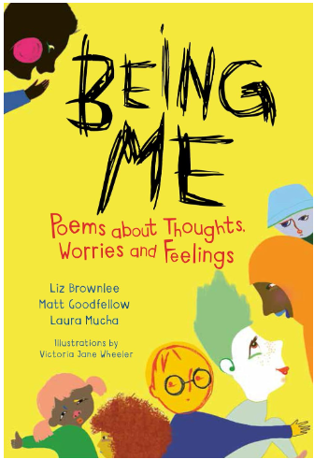  Format:  Poetry  Author:  Liz Brownlee, Matt Goodfellow & Laura Mucha | Key text:  Whole School Respect Day in Family Groups.  Book Name  My mouth is a volcano  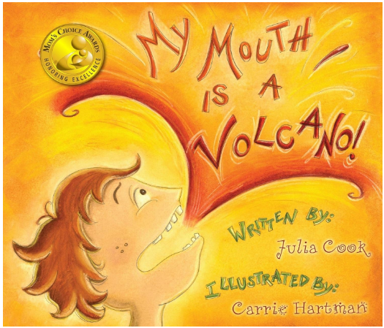  Format:  Picture book  Author:  Julia Cook | Key text:  Whole School Resilience Day in Family Groups.  Book Name  After the Fall  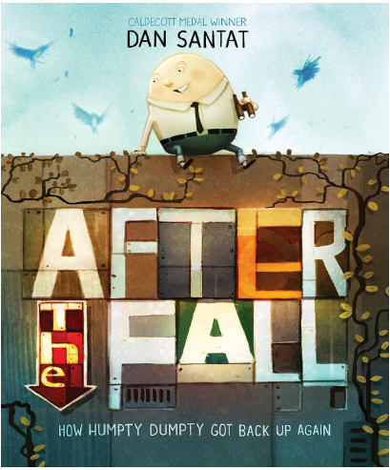  Format:  Graphic Novel  Author:  Dan Santat | Key text:  Whole School Integrity Day in Family Groups.  Book Name  The Magic Paintbrush  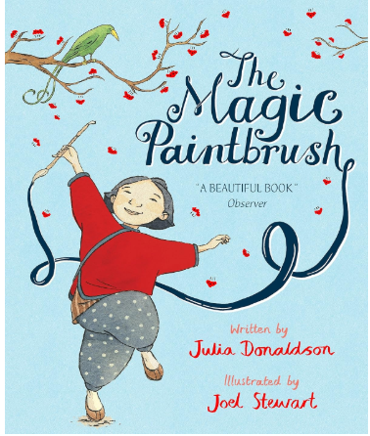  Format:  Picture book  Author:  Julia Donaldson | Key text:  Whole School Collaboration Day in Family Groups.  Book Name  What We’ll Build  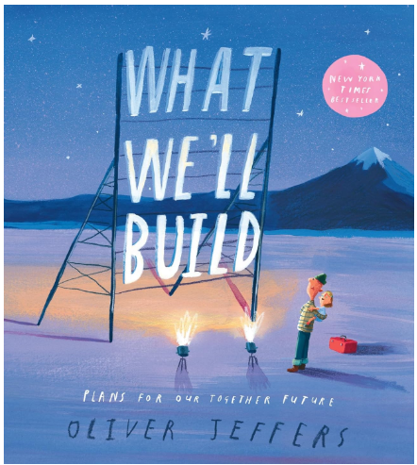  Format: Picture Book  Author: Oliver Jeffers | Key text:  Whole School Tenacity Day in Family Groups.  Book Name  All Sorts  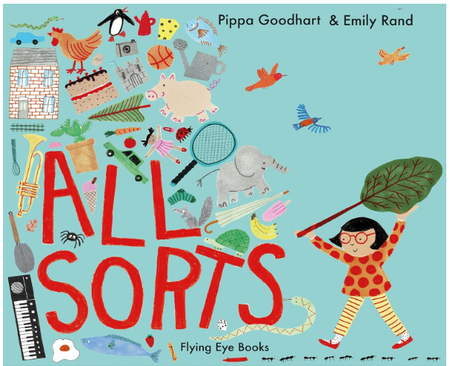  Format: Picture Book  Author: Pippa Goodhart and Emily Rand
Cycle A
Year 3/4
Growing Up Great Curriculum
Term/Subject | Autumn 1 | Autumn 2 | Spring 1 | Spring 2 | Summer 1 | Summer 2
Character Curriculum | Key text:  Whole School Kindness Day in Family Groups.  Book Name  Being me  Format:  Poetry  Author:  Liz Brownlee, Matt Goodfellow & Laura Mucha | Key text:  Whole School Respect Day in Family Groups.  Book Name  Lailah’s Lunchbox  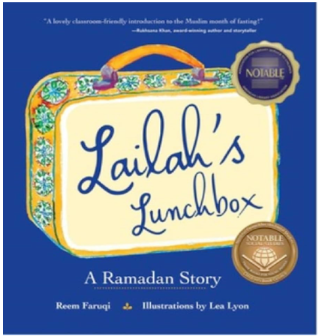  Format: Religious Fiction  Author:  Reem Faruqi | Key text:  Whole School Resilience Day in Family Groups.  Book Name  A better day: Your positive mental health handbook  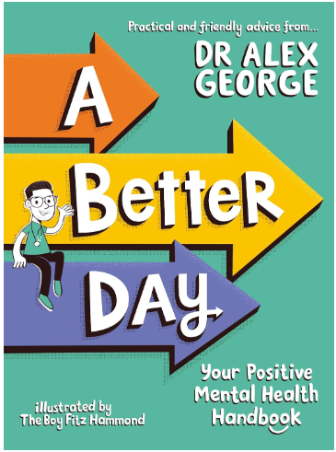  Format:  Non-fiction  Author:  Dr Alex George | Key text:  Whole School Integrity Day in Family Groups.  Book Name  The True Story of the Three Little Pigs  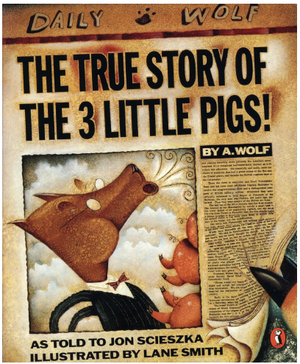  Format:  newspaper style  Author:  Jon Scieszka | Key text:  Whole School Collaboration Day in Family Groups.  Book Name  Cinnamon  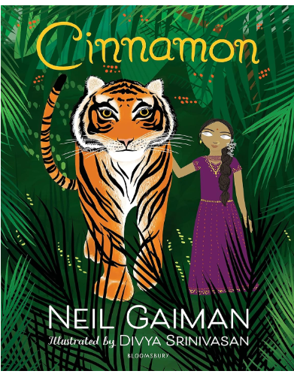  Format:  Fable  Author:  Neil Gaiman | Key text:  Whole School Tenacity Day in Family Groups.  Book Name  Break the Mould: How to Take Your Place in the World  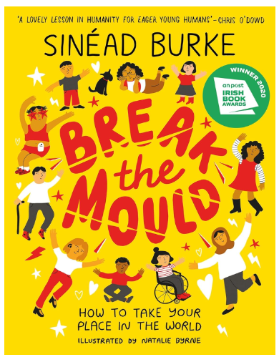  Format:  Non-fiction  Author:  Sinéad Burke
Cycle A
Year 5/6
Growing Up Great Curriculum
Term/Subject | Autumn 1 | Autumn 2 | Spring 1 | Spring 2 | Summer 1 | Summer 2
Character Curriculum | Key text:  Whole School Kindness Day in Family Groups.  Book Name  Being me  Format:  Poetry  Author:  Liz Brownlee, Matt Goodfellow & Laura Mucha | Key text:  Whole School Respect Day in Family Groups.  Book Name  Lailah’s Lunchbox  Format: Religious Fiction  Author:  Reem Faruqi | Key text:  Whole School Resilience Day in Family Groups.  Book Name  A better day: Your positive mental health handbook  Format:  Non-fiction  Author:  Dr Alex George | Key text:  Whole School Integrity Day in Family Groups.  Book Name  The True Story of the Three Little Pigs  Format:  newspaper style  Author:  Jon Scieszka | Key text:  Whole School Collaboration Day in Family Groups.  Book Name  Cinnamon  Format:  Fable  Author:  Neil Gaiman | Key text:  Whole School Tenacity Day in Family Groups.  Book Name  Break the Mould: How to Take Your Place in the World  Format:  Non-fiction  Author:  Sinéad Burke

