EYFS Curriculum Summer 2: 2024/2025
NURSERY RECEPTION
W/C | Week 1 | Week 2 | Week 3 | Week 4 |  |  | Week 5 |  | Week 6 | Week 7 | Week 8
Key Dates | 5th June – World Environment Day  8th June – World Oceans Day | 15th June – Father’s Day | 21st June – Summer Solstice  22nd June – National Rainforest Day | 23rd June – National Writing Day  29th June – International Mud Day |  |  |  |  |  | 16th July – Moon Landing Anniversary.
Themes | We are Explores:  - WK1: Under the Sea  - WK2: The Seaside Past and Present  - WK3: Insects  - WK4: Dinosaurs and Fossils (Mary Anning) |  |  |  |  |  | New beginnings:  - WK5: Summer  - WK6: New Beginnings (Preparing for Year1 / Reception)  - WK7: Transition week  - WK8: Transition week
Texts | Commotion in the Ocean  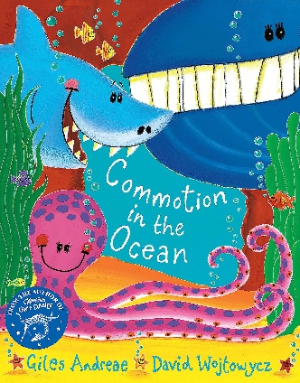 | The Sea Saw  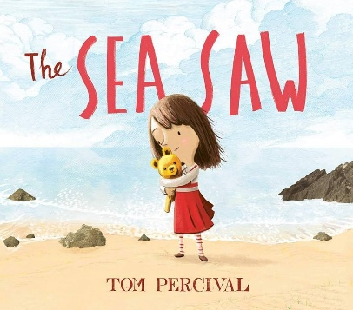 | The Snail and The Whale  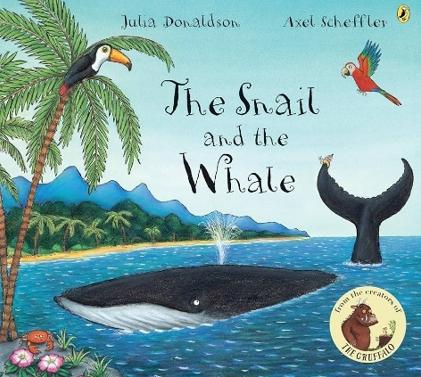 | Giganotosaurus  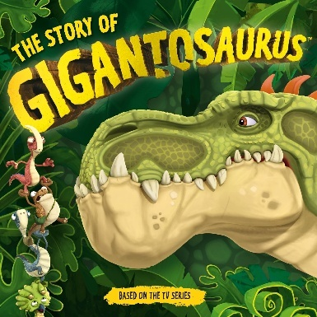 |  |  | The Lighthouse  Eat Your Peas Louise Dinnertime Rhyme  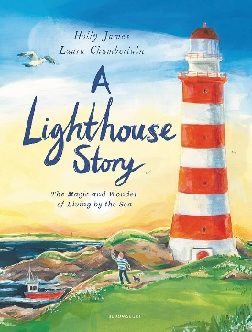 |  | Keepers Lunch  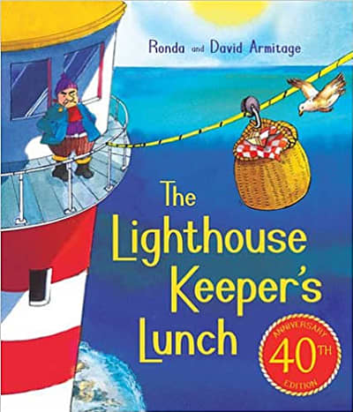 | Bloom  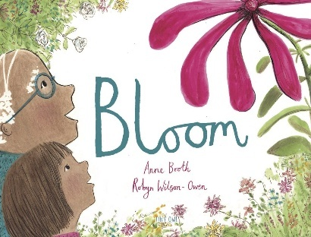 | GUG Book
WOW |  | - Father’s Day celebrations |  |  |  |  | - Summer walk |  |  | - Transition activities Nursery / Reception | - Transition activities Nursery / Reception
Songs and Rhymes | Days of the week  Months of the year  Twinkle Twinkle Little Star | Days of the week  Months of the year  At the seaside | Days of the week  Months of the year  Hickory Dickory Dock | Days of the week  Months of the year  Row Row Row Your Boat |  |  | Days of the week  Months of the year  Humpty Dumpty |  | Days of the week  Months of the year  Old MacDonald Had a Farm | Days of the week  Months of the year  Five Little Monkeys | Days of the week  Months of the year  Wheels On The Bus
C&L | NURSERY: 3-4 development matters  - Enjoy listening to longer stories and can remember much of what happens.  - Pay attention to more than one thing at a time, which can be difficult.  - Use a wider range of vocabulary.  - Understand a question or instruction that has two parts, such as: “Get your coat and wait at the door”.  - Understand ‘why’ questions, like: “Why do you think the gingerbread man ran away?”  - Sing a large repertoire of songs.  - Know many rhymes, be able to talk about familiar books, and be able to tell a long story.  - Develop their communication but may continue to have problems with irregular tenses and plurals, such as ‘runned’ for ‘ran’, ‘swimmed’ for ‘swam’.  - Develop their pronunciation but may have problems saying some sounds: r, j, th, ch, and sh.  - Use longer sentences of four to six words.  - Be able to express a point of view and to debate when they disagree with an adult or a friend, using words as well as actions.  - Start a conversation with an adult or a friend and continue it for many turns.  - Use talk to organise themselves and their play: “Let’s go on a bus... you sit there... I’ll be the driver.” |  |  |  |  | RECEPTION: Development matters reception  - Understand how to listen carefully and why listening is important.  - Learn new vocabulary.  - Use new vocabulary throughout the day.  - Ask questions to find out more and to check they understand what has been said to them.  - Articulate their ideas and thoughts in well-formed sentences.  - Connect one idea or action to another using a range of connectives.  - Describe events in some detail.  - Use talk to help work out problems and organise thinking and activities, and to explain how things work and why they might happen.  - Develop social phrases.  - Engage in story times.  - Listen to and talk about stories to build familiarity and understanding.  - Retell the story, once they have developed a deep familiarity with the text, some as exact repetition and some in their own words.  - Use new vocabulary in different contexts.  - Listen carefully to rhymes and songs paying attention to how they sound.  - Learn rhymes, poems, and songs.  - Engage in non-fiction books.  - Listen to and talk about selected non-fiction to develop deep familiarity, new knowledge, and vocabulary
Key Vocab | - Ocean  Seaside  - Marine  - Past  - Present  - Insects  - Dinosaurs  - Jurassic  - Many millions of years ago  - Mary Anning  - Palaeontologist  - Fossils  - Summer  - New beginnings  - Worries and wishes
Ideas | - Explore the vocabulary in our PTW texts  - Explore rhyme in our PTP texts  - Listen to focused text with lots of book talk  - Look at characters and develop character descriptions  - Explore how the characters of feeling in the story  - Focus on setting  - Sophia’s teddy visits the classroom  - Hot seating as Sofia and the teddy – how do they feel and why?  - The Seaside small world  - Dinosaur swamp small world  - Fossil hunting in the outdoor area  - Summer small world  - Lots of talk about the seasons and the changes they have noticed  I will be learning to identify and understand new vocabulary in our PTW texts.  I will be learning to observe and describe characters in the stories we read.  I will be learning to identify and express how characters are feeling in the story.  I will be learning to describe and understand the setting of a story.  I will be learning to take on the role of Sofia and the teddy and explore their feelings and motivations.  I will be learning to explore and create imaginative stories in a seaside small world.  I will be learning to engage in imaginative play and storytelling in a dinosaur swamp small world.  I will be learning to search for fossils and learn about them in the outdoor area.  I will be learning to use creative play to tell stories in a summer small world.  I will be learning to observe and discuss the changes in the seasons and how they affect the environment.
PSED | NURSERY: 3-4 development matters  - Select and use activities and resources, with help when needed. This helps them to achieve a goal they have chosen, or one which is suggested to them.  - Develop their sense of responsibility and membership of a community.  - Become more outgoing with unfamiliar people, in the safe context of their setting.  - Show more confidence in new social situations.  - Play with one or more other children, extending and elaborating play ideas.  - Find solutions to conflicts and rivalries.  - Increasingly follow rules, understanding why they are important.  - Remember rules without needing an adult to remind them.  - Develop appropriate ways of being assertive. Talk with others to solve conflicts.  - Talk about their feelings using words like ‘happy’, ‘sad’, ‘angry’ or ‘worried’.  - Understand gradually how others might be feeling. |  |  |  |  | RECEPTION: Development matters reception  - See themselves as a valuable individual.  - Build constructive and respectful relationships.  - Express their feelings and consider the feelings of others.  - Show resilience and perseverance in the face of a challenge.  - Identify and moderate their own feelings socially and emotionally.  - Think about the perspective of others.  - Manage their own needs – personal hygiene.  - Know and talk about the different factors that support their overall health and wellbeing.  - JIGSAW
Ideas | - Tidy up songs and routines  - Tidy up areas  - Pictures resources  - Character feelings in the text  - Role play / social stories on solving conflicts and rivalries  - Weekly Jigsaw PSHE sessions  - Changing me PSHE off time table (whole day)  I will be learning to follow tidy-up songs and routines.  I will be learning to tidy up different areas responsibly.  I will be learning to use pictures and resources effectively.  I will be learning to identify and understand character feelings in the text.  I will be learning to role-play and use social stories to solve conflicts and rivalries.  I will be learning to engage in weekly Jigsaw PSHE sessions to develop my social and emotional skills.
Physical | NURSERY: 3-4 development matters  - Continue to develop their movement, balancing, riding and ball skills.  - Go up steps and stairs, or climb up apparatus, using alternate feet.  - Skip, hop, stand on one leg, and hold a pose for a game like musical statues.  - Use large-muscle movements to wave flags and streamers, paint and make marks.  - Start taking part in some group activities which they make up for themselves, or in teams.  - Increasingly be able to use and remember sequences and patterns of movements which are related to music and rhythm.  - Match their developing physical skills to tasks and activities in the setting. For example, they decide whether to crawl, walk or run across a plank, depending on its length and width.  - Choose the right resources to carry out their own plan. For example, choosing a spade to enlarge a small hole they dug with a trowel.  - Collaborate with others to manage large items, such as moving a long plank safely, carrying large hollow blocks.  - Use one-handed tools and equipment, for example, making snips in paper with scissors.  - Use a comfortable grip with good control when holding pens and pencils.  - Show a preference for a dominant hand.  - Be increasingly independent as they get dressed and undressed, for example, putting coats on and doing up zips. |  |  |  |  | RECEPTION: Development matters reception  - Revise and refine the fundamental movement skills they have already acquired: rolling, crawling, walking, jumping, running, hopping, skipping, climbing.  - Progress towards a more fluent style of moving, with developing control and grace.  - Develop the overall body strength, co-ordination, balance, and agility needed to engage successfully with future physical education sessions.  - Develop their small motor skills so that they can use a range of tools competently, safely, and confidently.  - Use their core muscle strength to achieve a good posture when sitting at a table or sitting on the floor.  - Combine different movements with ease and fluency.  - Confidently and safely use a range of large and small apparatus indoors and outside, alone and in a group.  - Develop overall body-strength, balance, co-ordination, and agility.  - Further develop and refine a range of ball skills.  - Develop confidence, competence, precision, and accuracy when engaging in activities that involve a ball.  - Further develop and refine a range of ball skills including throwing, catching, kicking, passing, batting, and aiming.  - Develop confidence, competence, precision, and accuracy when engaging in activities that involve a ball.  - Further develop the skills they need to manage the school day successfully: lining up/ queuing/ mealtimes  - GET SET 4 PE
Ideas | - Weekly PE  - Squiggle while you wiggle  - Dough disco  Fine motor in CP  - Fine motor challenges  - Name writing  - Under the sea project  - Building a bug house  - Junk modelling dinosaurs  - Summer observational drawings  - End of year self portraits  - Fossil hunting  - Salt dough fossils  I will be learning to strengthen my hands and fingers through Dough Disco activities.  I will be learning to improve my fine motor skills in the continuous provision (CP) area..  I will be learning to explore and create during the "Under the Sea" project.  I will be learning to build a bug house and learn about habitats.  I will be learning to use junk modelling to create dinosaur models.  I will be learning to observe and draw summer scenes with attention to detail.  I will be learning to create self-portraits to reflect on myself at the end of the year.  I will be learning to search for fossils and understand how they are formed.  I will be learning to make salt dough fossils and explore how fossils are created.
Maths | NURSERY: 3-4 development matters  - Develop fast recognition of up to 3 objects, without having to count them individually (‘subitising’).  - Recite numbers past 5.  - Say one number for each item in order: 1,2,3,4,5.  - Know that the last number reached when counting a small set of objects tells you how many there are in total.  - Show ‘finger numbers’ up to 5.  - Link numerals and amounts: for example, showing the right number of objects to match the numeral, up to 5.  - Experiment with their own symbols and marks as well as numerals.  - Solve real world mathematical problems with numbers up to 5.  - Compare quantities using language: ‘more than’, ‘fewer than’.  - Talk about and explore 2D and 3D shapes.  - Understand position through words alone!  - Describe a familiar route.  - Discuss routes and locations, using words like ‘in front of’ and ‘behind’.  - Make comparisons between objects relating to size, length, weight, and capacity.  - Combine shapes to make new ones – an arch, a bigger triangle, etc.  - Talk about and identify the patterns around them.  - Extend and create ABAB patterns.  - Notice and correct an error in a repeating pattern.  - Begin to describe a sequence of events, real or fictional, using words such as ‘first’, ‘then...’ |  |  |  |  |  |  | RECEPTION: Development matters reception  - Count objects, actions, and sounds.  - Subitise.  - Link the number symbol (numeral) with its cardinal number value.  - Count beyond ten.  - Compare numbers.  - Understand the ‘one more than/one less than’ relationship between consecutive numbers.  - Explore the composition of numbers to 10.  - Automatically recall number bonds for numbers 0–5 and some to 10.  - Select, rotate, and manipulate shapes to develop spatial reasoning skills.  - Compose and decompose shapes so that children recognise a shape can have other shapes within it, just as numbers can.  - Continue, copy, and create repeating patterns.  - Compare length, weight, and capacity.
Key Vocab | - Number Facts  - Counting Skills  - Larger Sets  - Counting Actions  - Counting Sounds  - Representations of Numbers  - 10-Frame  - Doubles  - Magnitude  - Quantities  - Attributes  - Generalisation  - One More Than  - One Less Than  - Subitising  - Conceptual Subitising  - Rekenrek
Ideas | Pupils will consolidate their counting skills, counting to larger numbers and developing a wider range of counting strategies.  They will secure knowledge of number facts through varied practice. Pupils will:  - continue to develop their counting skills, counting larger sets as well as counting actions and sounds  - explore a range of representations of numbers, including the 10-frame, and see how doubles can be arranged in a 10-frame  - compare quantities and numbers, including sets of objects which have different attributes  - continue to develop a sense of magnitude, e.g. knowing that 8 is quite a lot more than 2, but 4 is only a little bit more than 2begin to generalise about ‘one more than’ and ‘one less than’ numbers within 10  - continue to identify when sets can be subitised and when counting is necessary • develop conceptual subitising skills including when using a rekenrek  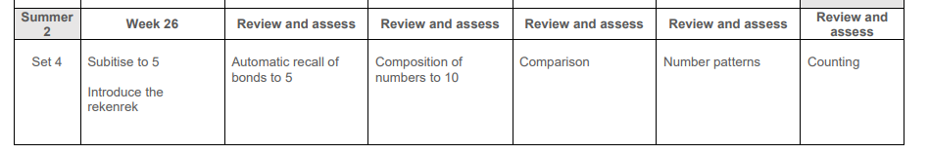  I will be continuing to develop my counting skills by counting larger sets, actions, and sounds.  I will be exploring different representations of numbers, including the 10-frame, and understanding how doubles can be arranged in a 10-frame.  I will be comparing quantities and numbers, even when the sets of objects have different attributes.  I will be developing a sense of magnitude, understanding that 8 is much more than 2, while 4 is only a little more than 2, and I will begin to generalize about 'one more than' and 'one less than' numbers within 10.  I will be identifying when sets can be subitised and when I need to count them.  I will be developing my conceptual subitising skills, especially when using a rekenrek.
Literacy | NURSERY: 3-4 development matters  - Understand the five key concepts about print:  - print has meaning.  - print can have different purposes.  - we read English text from left to right and from top to bottom.  - the names of the different parts of a book  - page sequencing  - Develop their phonological awareness, so that they can:  - spot and suggest rhymes.  - count or clap syllables in a word.  - recognise words with the same initial sound, such as money and mother.  - Engage in extended conversations about stories, learning new vocabulary.  - Use some of their print and letter knowledge in their early writing.  - Write some or all their name.  - Write some letters accurately. |  |  |  |  | RECEPTION: Development matters reception  - Read individual letters by saying the sounds for them.  - Blend sounds into words, so that they can read short words made up of known letter-sound correspondences.  - Read some letter groups that each represent one sound and say sounds for them.  - Read a few common exception words matched to the school’s phonic programme.  - Read simple phrases and sentences made up of words with known letter–sound correspondences and, where necessary, a few exception words.  - Re-read these books to build up their confidence in word reading, their fluency and their understanding and enjoyment.  - Form lower-case and capital letters correctly.  - Spell words by identifying the sounds and then writing the sound with letter/s.  - Write short sentences with words with known sound-letter correspondences using a capital letter and full stop.  - Re-read what they have written to check that it makes sense.
Key Vocab | - Author  - Title  - Blurb  - Illustrations  - Genre  - Plot  - Characters  - Setting
Ideas | - Daily Storytimes looking at the author, titles and blurbs.  - Introduce red words and challenge words for the week – display around the classroom.  - RWInc lessons  - PTW lessons  - PTP lessons  - Writing CVC words / CVC labelling challenge  - Fred Games  - Daily fine motor activities to develop fine motor skills  - Pinny time  - Red word challenges  - Fix my sentence  - Seaside and summer books  - Re-write / Re-tell a story  - Design your own dinosaur  I will be learning to listen to daily Storytimes, exploring the author, titles, and blurbs.  I will be learning to write and label CVC words during the CVC labelling challenge.  I will be learning to play Fred Games to practice blending and segmenting sounds.  I will be learning to develop my fine motor skills through daily fine motor activities.  I will be learning to fix sentences to improve their structure and meaning.  I will be learning to enjoy and explore seaside and summer-themed books.  I will be learning to re-write and re-tell a story in my own words.  I will be learning to design my own dinosaur, using creativity and imagination.
UW | NURSERY: 3-4 development matters  - Use all their senses in hands-on exploration of natural materials.  - Explore collections of materials with similar and/or different properties  - Talk about what they see, using a wide vocabulary.  - Begin to make sense of their own life-story and family’s history.  - Show interest in different occupations.  - Explore how things work.  - Plant seeds and care for growing plants.  - Understand the key features of the life cycle of a plant and an animal.  - Begin to understand the need to respect and care for the natural environment and all living things.  - Talk about the differences between materials and changes they notice.  - Explore and talk about different forces they can feel.  - Continue developing positive attitudes about the differences between people.  - Know that there are different countries in the world and talk about the difference they have experienced or seen in photos. |  |  |  | RECEPTION: Development matters reception  - Talk about members of their family and community.  - Name and describe people who are familiar to them.  - Comment on images of familiar situations in the past.  - Compare and contrast characters from stories, including figures from the past.  - Draw information from a simple map.  - Understand that some places are special to members of their community.  - Recognise that people have different beliefs and celebrate special times in different ways.  - Recognise some similarities and differences between life in this country and life in other countries.  - Explore the natural world around them.  - Describe what they see, hear, and feel whilst outside.  - Understand the effect of changing seasons on the natural world around them.  - Recognise some environments that are different from the one in which they live.
Ideas | - Look at different habitats under the sea  - Careers day  When I grow up I want to be…  - Sand activities  - Beach visit  - Compare beaches in other countries  - Create a senses map of what we experienced at the beach  - Summer walk  - What did we find at the beach?  - Frozen ice activities  - Look at Mary Anning  I will be learning how to create fun sculptures and patterns in the sand, using different tools and techniques.  I will be learning about the environment and ecosystems at the beach during a hands-on visit.  I will be learning how beaches differ in various parts of the world, from the sand to the animals that live there.  I will be learning how to use my senses to explore the beach and map out everything I hear, see, smell, and feel.  I will be learning about the plants, animals, and changes in nature during a summer walk outside.  I will be learning about different objects and creatures I can find at the beach, and what they tell us about the environment.  I will be learning how ice changes and melts in different temperatures and experimenting with frozen ice activities.
E&D | NURSERY: 3-4 development matters  - Take part in simple pretend play.  - Begin to develop complex stories using small world equipment.  - Explore different materials freely, to develop their ideas about how to use them and what to make.  - Develop their own ideas and then decide which materials to use to express them.  - Join different materials and explore different textures.  - Create closed shapes with continuous lines and begin to use these shapes to represent objects.  - Draw with increasing complexity and detail, such as representing a face with a circle and including details.  - Use drawing to represent ideas like movement or loud noises.  - Show different emotions in their drawings and paintings.  - Explore colour and colour mixing.  - Listen with increased attention to sounds: Respond to what they have heard, expressing their thoughts and feelings.  - Remember and sing entire songs.  - Sing the pitch of a tone sung by another person.  - Sing the melodic shape of familiar songs.  - Create their own songs or improvise a song around one they know.  - Play instruments with increasing control to express their feelings and ideas. |  |  |  |  | RECEPTION: Development matters reception  - Explore, use, and refine a variety of artistic effects to express their ideas and feelings.  - Return to and build on their previous learning, refining ideas and developing their ability to represent them.  - Create collaboratively, sharing ideas, resources, and skills.  - Listen attentively, move to, and talk about music, expressing their feelings and responses.  - Watch and talk about dance and performance art, expressing their feelings and responses.  - Sing in a group or on their own, increasingly matching the pitch and following the melody.  - Develop storylines in their pretend play.
Ideas | - Small world (different jobs)  - Beach themed painting  - Exploring different textiles  - Making a puppet for a beach puppet show  - Graduation songs  - Summer transient art  - Small world dinosaurs  - Making fossils out of salt dough  - Underwater animal’s small world  - The beach shop – role play  I will be learning about different jobs by exploring a small world of various careers and their roles.  I will be learning how to create a beach-themed painting using different techniques and colours.  I will be learning about different textiles and how they are used in art and clothing.  I will be learning how to make a puppet for a beach puppet show, exploring materials and crafting techniques.  I will be learning graduation songs and practicing how to sing them for the ceremony.  I will be learning how to create transient art by using natural materials found outside during the summer.  I will be learning about dinosaurs by exploring a small world setting filled with prehistoric creatures.  I will be learning how to make fossils using salt dough, experimenting with textures and shapes.  I will be learning about underwater animals by creating a small world that represents ocean life.
KS1  Curriculum Links | - Living Things and their Habitats- Year 2  - Famous Scientists  - Travel and Exploration
Home Learning | Weekly maths  Weekly phonics (reception)  Weekly reading  Weekly curriculum | Weekly maths  Weekly phonics (reception)  Weekly reading  Weekly curriculum | Weekly maths  Weekly phonics (reception)  Weekly reading  Weekly curriculum | Weekly maths  Weekly phonics (reception)  Weekly reading  Weekly curriculum |  |  | Weekly maths  Weekly phonics (reception)  Weekly reading  Weekly curriculum |  | Weekly maths  Weekly phonics (reception)  Weekly reading  Weekly curriculum | Weekly maths  Weekly phonics (reception)  Weekly reading  Weekly curriculum | Weekly maths  Weekly phonics (reception)  Weekly reading  Weekly curriculum

