EYFS Curriculum Summer 1: 2024/2025
NURSERY RECEPTION
W/C | Week 1 | Week 2 | Week 3 |  |  | Week 4 |  | Week 5
Key Dates | 22nd April – Earth Day  23rd April – St George’s Day | 1st May – May Day | 5th May – African World Heritage Day  10th May – Fair Trade Day |  |  | 16th May – Endangered Species Day |  | 20th May – World Bee Day
Themes | Farm, Food & Growing:  - Week 1: Planet Earth / Recycling  - Week 2: The Royal Family / London  - Week 3: Africa  - Week 4: Plants and Growing  - Week 5: Bees
Texts | 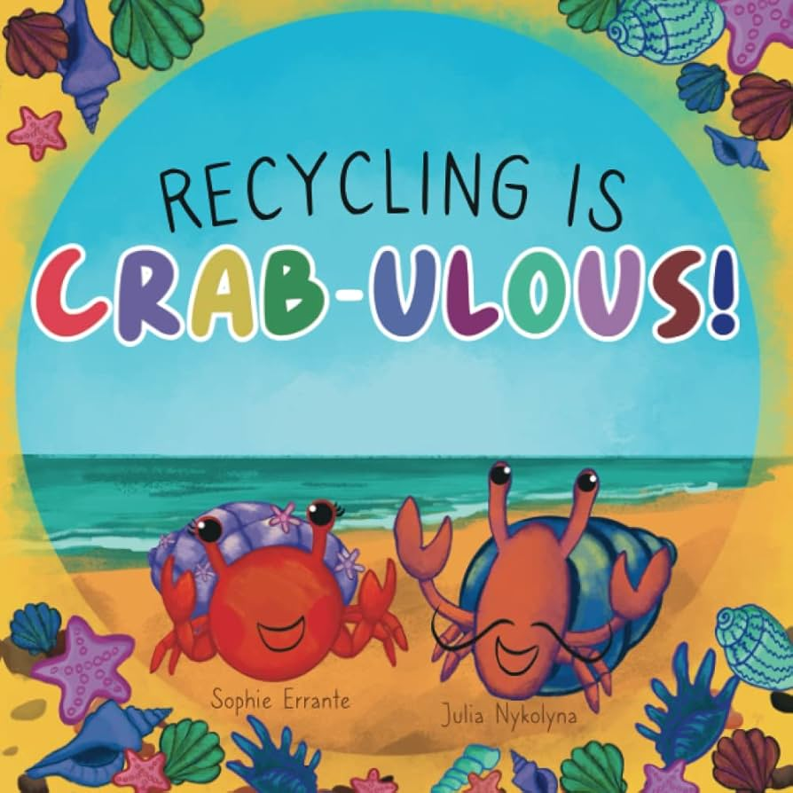  Recycling is crab-ulous  Silly Doggy | 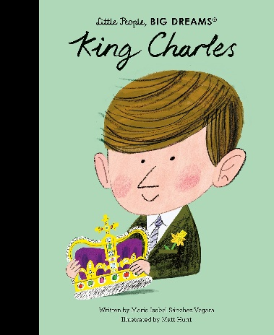  Little People Big Dreams – King Charles | 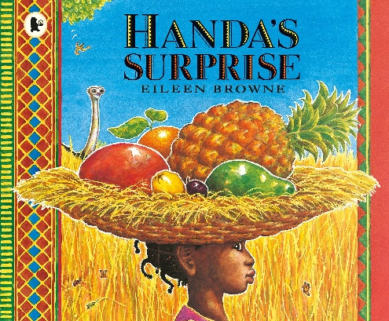  Handa’s Surprise |  |  | 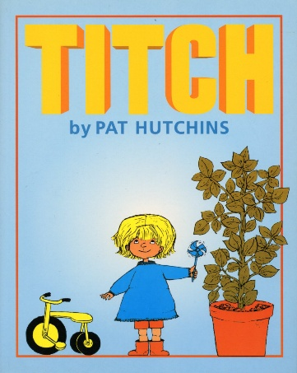  Titch  Earth Poems |  | 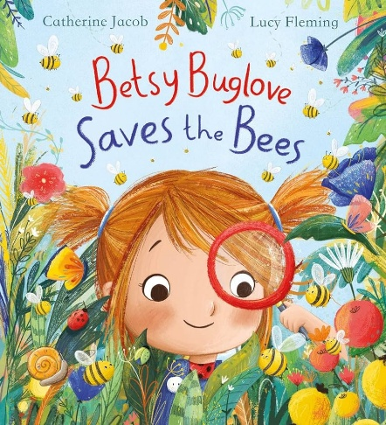  Betsy Buglove Saves the Bees
WOW | Earth day celebrations | St Georges Day ‘street party’ | Taste African food |  |  | Growing plants and vegetables
Songs and Rhymes | Old MacDonald Had a Farm. | Little Bo Peep Has Lost her Sheep. | 5 Little Ducks. |  |  | Mary Had a Little Lamb. |  | Baa Baa Black Sheep
C&L | NURSERY: 3-4 development matters  - Enjoy listening to longer stories and can remember much of what happens.  - Pay attention to more than one thing at a time, which can be difficult.  - Use a wider range of vocabulary.  - Understand a question or instruction that has two parts, such as: “Get your coat and wait at the door”.  - Understand ‘why’ questions, like: “Why do you think the gingerbread man ran away?”  - Sing a large repertoire of songs.  - Know many rhymes, be able to talk about familiar books, and be able to tell a long story.  - Develop their communication but may continue to have problems with irregular tenses and plurals, such as ‘runned’ for ‘ran’, ‘swimmed’ for ‘swam’.  - Develop their pronunciation but may have problems saying some sounds: r, j, th, ch, and sh.  - Use longer sentences of four to six words.  - Be able to express a point of view and to debate when they disagree with an adult or a friend, using words as well as actions.  - Start a conversation with an adult or a friend and continue it for many turns.  - Use talk to organise themselves and their play: “Let’s go on a bus... you sit there... I’ll be the driver.” |  |  |  | RECEPTION: Development matters reception  - Understand how to listen carefully and why listening is important.  - Learn new vocabulary.  - Use new vocabulary throughout the day.  - Ask questions to find out more and to check they understand what has been said to them.  - Articulate their ideas and thoughts in well-formed sentences.  - Connect one idea or action to another using a range of connectives.  - Describe events in some detail.  - Use talk to help work out problems and organise thinking and activities, and to explain how things work and why they might happen.  - Develop social phrases.  - Engage in story times.  - Listen to and talk about stories to build familiarity and understanding.  - Retell the story, once they have developed a deep familiarity with the text, some as exact repetition and some in their own words.  - Use new vocabulary in different contexts.  - Listen carefully to rhymes and songs paying attention to how they sound.  - Learn rhymes, poems, and songs.  - Engage in non-fiction books.  - Listen to and talk about selected non-fiction to develop deep familiarity, new knowledge, and vocabulary
Key Vocab | - Recycling  - Earth  - Plant  - Look after.  - Royal Family  - King / Queen  - Monarchy  - London  - Capital City  - Africa  - Plants  - Growing  - Bees  - Pollination
Ideas | - Explore the vocabulary in our PTW texts  - Explore rhyme in our PTP texts  - Refocus on recycling – why is it important  - Litter picking around the school / local community  - London small world  - fairy tale kingdom small world  - Look at the story Handa’s surprise – sequence the events  - Retell the text Silly Doggy  - Sing daily rhymes  - Explore vocabulary in key texts  - Follow instructions to plan vegetables and flowers  - Virtual African safari – what can they see.  I will be exploring the vocabulary in our PTW texts.  I will be exploring rhyme in our PTP texts.  I will be refocusing on recycling – why is it important?  I will be litter picking around the school/local community.  I will be exploring a London small world.  I will be exploring a fairy tale kingdom small world.  I will be sequencing the events in Handa’s Surprise.  I will be retelling the text Silly Doggy.  I will be singing daily rhymes.  I will be exploring vocabulary in key texts.  I will be following instructions to plant vegetables and flowers.  I will be going on a virtual African safari – what can I see?
PSED | NURSERY: 3-4 development matters  - Select and use activities and resources, with help when needed. This helps them to achieve a goal they have chosen, or one which is suggested to them.  - Develop their sense of responsibility and membership of a community.  - Become more outgoing with unfamiliar people, in the safe context of their setting.  - Show more confidence in new social situations.  - Play with one or more other children, extending and elaborating play ideas.  - Find solutions to conflicts and rivalries.  - Increasingly follow rules, understanding why they are important.  - Remember rules without needing an adult to remind them.  - Develop appropriate ways of being assertive. Talk with others to solve conflicts.  - Talk about their feelings using words like ‘happy’, ‘sad’, ‘angry’ or ‘worried’.  - Understand gradually how others might be feeling. |  |  |  | RECEPTION: Development matters reception  - See themselves as a valuable individual.  - Build constructive and respectful relationships.  - Express their feelings and consider the feelings of others.  - Show resilience and perseverance in the face of a challenge.  - Identify and moderate their own feelings socially and emotionally.  - Think about the perspective of others.  - Manage their own needs – personal hygiene.  - Know and talk about the different factors that support their overall health and wellbeing.
Ideas | - Tidy up songs and routines  - Tidy up areas  - Pictures resources  - Character feelings in the text  - Role play / social stories on solving conflicts and rivalries  - Weekly Jigsaw PSHE sessions  - Look at relationships and about healthy boundaries and respect.  I will be singing tidy-up songs and following routines.  I will be tidying up areas to keep our space clean and organized.  I will be using pictures and resources to support my learning.  I will be identifying character feelings in the text.  I will be role-playing and using social stories to solve conflicts and rivalries.  I will be participating in weekly Jigsaw PSHE sessions.  I will be learning about relationships, healthy boundaries, and respect.
Physical | NURSERY: 3-4 development matters  - Continue to develop their movement, balancing, riding and ball skills.  - Go up steps and stairs, or climb up apparatus, using alternate feet.  - Skip, hop, stand on one leg, and hold a pose for a game like musical statues.  - Use large-muscle movements to wave flags and streamers, paint and make marks.  - Start taking part in some group activities which they make up for themselves, or in teams.  - Increasingly be able to use and remember sequences and patterns of movements which are related to music and rhythm.  - Match their developing physical skills to tasks and activities in the setting. For example, they decide whether to crawl, walk or run across a plank, depending on its length and width.  - Choose the right resources to carry out their own plan. For example, choosing a spade to enlarge a small hole they dug with a trowel.  - Collaborate with others to manage large items, such as moving a long plank safely, carrying large hollow blocks.  - Use one-handed tools and equipment, for example, making snips in paper with scissors.  - Use a comfortable grip with good control when holding pens and pencils.  - Show a preference for a dominant hand.  - Be increasingly independent as they get dressed and undressed, for example, putting coats on and doing up zips. |  |  |  | RECEPTION: Development matters reception  - Revise and refine the fundamental movement skills they have already acquired: rolling, crawling, walking, jumping, running, hopping, skipping, climbing.  - Progress towards a more fluent style of moving, with developing control and grace.  - Develop the overall body strength, co-ordination, balance, and agility needed to engage successfully with future physical education sessions.  - Develop their small motor skills so that they can use a range of tools competently, safely, and confidently.  - Use their core muscle strength to achieve a good posture when sitting at a table or sitting on the floor.  - Combine different movements with ease and fluency.  - Confidently and safely use a range of large and small apparatus indoors and outside, alone and in a group.  - Develop overall body-strength, balance, co-ordination, and agility.  - Further develop and refine a range of ball skills.  - Develop confidence, competence, precision, and accuracy when engaging in activities that involve a ball.  - Further develop and refine a range of ball skills including throwing, catching, kicking, passing, batting, and aiming.  - Develop confidence, competence, precision, and accuracy when engaging in activities that involve a ball.  - Further develop the skills they need to manage the school day successfully: lining up/ queuing/ mealtimes
Ideas | - Weekly PE  - Squiggle while you wiggle  - Dough discoes  Fine motor in CP.  - Fine motor challenges  - Name writing  - Litter picking around school/local area  - Posters on recycling  - Planting seeds and bulbs  I will be participating in weekly PE sessions.  I will be doing Squiggle while you wiggle to improve my movement skills.  I will be practicing Dough Disco to strengthen my hand muscles.  I will be working on fine motor skills in CP.  I will be taking on fine motor challenges to improve my coordination.  I will be practicing name writing to develop my handwriting skills.  I will be litter picking around the school or local area to help keep it clean.  I will be creating posters on recycling to raise awareness.  I will be planting seeds and bulbs to learn about growth and nature.
Maths | NURSERY: 3-4 development matters  - Develop fast recognition of up to 3 objects, without having to count them individually (‘subitising’).  - Recite numbers past 5.  - Say one number for each item in order: 1,2,3,4,5.  - Know that the last number reached when counting a small set of objects tells you how many there are in total.  - Show ‘finger numbers’ up to 5.  - Link numerals and amounts: for example, showing the right number of objects to match the numeral, up to 5.  - Experiment with their own symbols and marks as well as numerals.  - Solve real world mathematical problems with numbers up to 5.  - Compare quantities using language: ‘more than’, ‘fewer than’.  - Talk about and explore 2D and 3D shapes.  - Understand position through words alone!  - Describe a familiar route.  - Discuss routes and locations, using words like ‘in front of’ and ‘behind’.  - Make comparisons between objects relating to size, length, weight, and capacity.  - Combine shapes to make new ones – an arch, a bigger triangle, etc.  - Talk about and identify the patterns around them.  - Extend and create ABAB patterns.  - Notice and correct an error in a repeating pattern.  - Begin to describe a sequence of events, real or fictional, using words such as ‘first’, ‘then...’ |  |  |  |  |  | RECEPTION: Development matters reception  - Count objects, actions, and sounds.  - Subitise.  - Link the number symbol (numeral) with its cardinal number value.  - Count beyond ten.  - Compare numbers.  - Understand the ‘one more than/one less than’ relationship between consecutive numbers.  - Explore the composition of numbers to 10.  - Automatically recall number bonds for numbers 0–5 and some to 10.  - Select, rotate, and manipulate shapes to develop spatial reasoning skills.  - Compose and decompose shapes so that children recognise a shape can have other shapes within it, just as numbers can.  - Continue, copy, and create repeating patterns.  - Compare length, weight, and capacity.
Key Vocab | - Counting  - 10-frame  - Doubles  - Number comparison  - Sets of objects  - Different attributes  - Sense of magnitude  - Greater than  - Less than  - More than  - A little bit more  - Quite a lot more  - Number sequence  - Number patterns  - Subitising  - Rekenrek
Ideas | 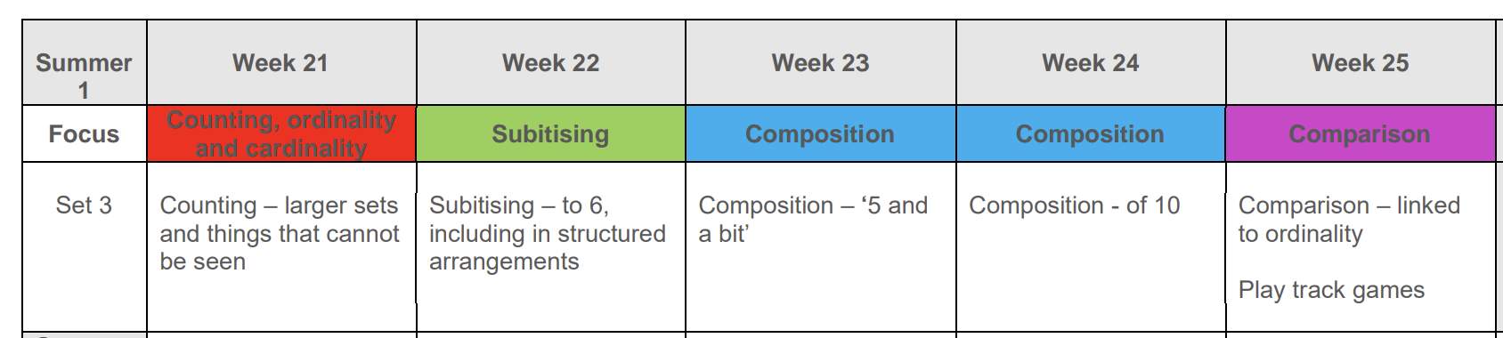  Pupils will consolidate their counting skills, counting to larger numbers and developing a wider range of counting strategies. They will secure knowledge of number facts through varied practice.  Pupils will:  - continue to develop their counting skills, counting larger sets as well as counting actions and sounds.  - explore a range of representations of numbers, including the 10-frame, and see how doubles can be arranged in a 10-frame.  - compare quantities and numbers, including sets of objects which have different attributes.  - continue to develop a sense of magnitude, e.g., knowing that 8 is quite a lot more than 2, but 4 is only a little bit more than 2.  - begin to generalise about ‘one more than’ and ‘one less than’ numbers within 10.  - continue to identify when sets can be subitised and when counting is necessary.  - develop conceptual subitising skills including when using a rekenrek.  I will be continuing to develop my counting skills, counting larger sets as well as counting actions and sounds.  I will be exploring a range of representations of numbers, including the 10-frame, and seeing how doubles can be arranged in a 10-frame.  I will be comparing quantities and numbers, including sets of objects with different attributes.  I will be developing a sense of magnitude, understanding that 8 is much more than 2, but 4 is only a little bit more than 2.  I will be beginning to generalize about ‘one more than’ and ‘one less than’ numbers within 10.  I will be identifying when sets can be subitised and when counting is necessary.  I will be developing my conceptual subitising skills, including when using a rekenrek.
Literacy | NURSERY: 3-4 development matters  - Understand the five key concepts about print:  - print has meaning.  - print can have different purposes.  - we read English text from left to right and from top to bottom.  - the names of the different parts of a book  - page sequencing  - Develop their phonological awareness, so that they can:  - spot and suggest rhymes.  - count or clap syllables in a word.  - recognise words with the same initial sound, such as money and mother.  - Engage in extended conversations about stories, learning new vocabulary.  - Use some of their print and letter knowledge in their early writing.  - Write some or all their name.  - Write some letters accurately. |  |  |  | RECEPTION: Development matters reception  - Read individual letters by saying the sounds for them.  - Blend sounds into words, so that they can read short words made up of known letter-sound correspondences.  - Read some letter groups that each represent one sound and say sounds for them.  - Read a few common exception words matched to the school’s phonic programme.  - Read simple phrases and sentences made up of words with known letter–sound correspondences and, where necessary, a few exception words.  - Re-read these books to build up their confidence in word reading, their fluency and their understanding and enjoyment.  - Form lower-case and capital letters correctly.  - Spell words by identifying the sounds and then writing the sound with letter/s.  - Write short sentences with words with known sound-letter correspondences using a capital letter and full stop.  - Re-read what they have written to check that it makes sense.
Key Vocab | - Recycling  - Earth  - Plant  - Look after.  - Royal Family  - King / Queen  - Monarchy  - London  - Capital City  - Africa  - Plants  - Growing  - Bees
Ideas | - Daily story times looking at the author, titles, and blurbs.  - Introduce red words and challenge words for the week – display around the classroom  - RWInc lessons  - PTW lessons  - PTP lessons  - Writing CVC words  - Fred Games  - Daily fine motor activities to develop fine motor skills  - Pinny time  - Fred Frog and Special friend challenges  - Red word challenges  - Books on London and The Royal Family  - Books about Africa  I will be participating in daily story times, looking at the author, titles, and blurbs.  I will be learning new red words and challenge words for the week and displaying them around the classroom.  I will be engaging in RWInc lessons to develop my reading and phonics skills.  I will be learning in PTW lessons to explore different topics and develop new skills.  I will be participating in PTP lessons to improve my understanding and knowledge.  I will be writing CVC words to practice spelling and letter recognition.  I will be playing Fred Games to improve my phonics and reading skills.  I will be participating in daily fine motor activities to develop my fine motor skills.  I will be taking part in Pinny time to improve my listening and communication skills.  I will be completing Fred Frog and Special friend challenges to practice my phonics.  I will be participating in red word challenges to improve my sight word recognition.
UW | NURSERY: 3-4 development matters  - Use all their senses in hands-on exploration of natural materials.  - Explore collections of materials with similar and/or different properties  - Talk about what they see, using a wide vocabulary.  - Begin to make sense of their own life-story and family’s history.  - Show interest in different occupations.  - Explore how things work.  - Plant seeds and care for growing plants.  - Understand the key features of the life cycle of a plant and an animal.  - Begin to understand the need to respect and care for the natural environment and all living things.  - Talk about the differences between materials and changes they notice.  - Explore and talk about different forces they can feel.  - Continue developing positive attitudes about the differences between people.  - Know that there are different countries in the world and talk about the difference they have experienced or seen in photos. |  |  | RECEPTION: Development matters reception  - Talk about members of their family and community.  - Name and describe people who are familiar to them.  - Comment on images of familiar situations in the past.  - Compare and contrast characters from stories, including figures from the past.  - Draw information from a simple map.  - Understand that some places are special to members of their community.  - Recognise that people have different beliefs and celebrate special times in different ways.  - Recognise some similarities and differences between life in this country and life in  - other countries.  - Explore the natural world around them.  - Describe what they see, hear, and feel whilst outside.  - Understand the effect of changing seasons on the natural world around them.  - Recognise some environments that are different from the one in which they live.  - Describe that they see, feel, and hear whilst outside.
Ideas | - Handa’s Surprise – explore Africa and different cultures.  - African dancing workshop  - Tasting African foods  - Looking at the different clothing and patterns on the clothing  - Compare the weather on the BBC weather app  - Summer walks  - Ice melting observations  - Plant cress heads, sunflowers, grass tuff tray for bug small world play, discussing plant needs for growth and observing processes.  I will be exploring Africa and different cultures through Handa’s Surprise.  I will be participating in an African dancing workshop to learn about dance and culture.  I will be tasting African foods to explore new flavours and culinary traditions.  I will be looking at different clothing and patterns to understand cultural styles.  I will be comparing the weather using the BBC weather app to observe differences and trends.  I will be going on summer walks to explore nature and the outdoors.  I will be making ice melting observations to understand how ice changes with temperature.  I will be planting cress heads, sunflowers, and creating a grass tuff tray for bug small world play while discussing plant needs for growth and observing the process.
E&D | NURSERY: 3-4 development matters  - Take part in simple pretend play.  - Begin to develop complex stories using small world equipment.  - Explore different materials freely, to develop their ideas about how to use them and what to make.  - Develop their own ideas and then decide which materials to use to express them.  - Join different materials and explore different textures.  - Create closed shapes with continuous lines and begin to use these shapes to represent objects.  - Draw with increasing complexity and detail, such as representing a face with a circle and including details.  - Use drawing to represent ideas like movement or loud noises.  - Show different emotions in their drawings and paintings.  - Explore colour and colour mixing.  - Listen with increased attention to sounds: Respond to what they have heard, expressing their thoughts and feelings.  - Remember and sing entire songs.  - Sing the pitch of a tone sung by another person.  - Sing the melodic shape of familiar songs.  - Create their own songs or improvise a song around one they know.  - Play instruments with increasing control to express their feelings and ideas. |  |  |  | RECEPTION: Development matters reception  - Explore, use, and refine a variety of artistic effects to express their ideas and feelings.  - Return to and build on their previous learning, refining ideas and developing their ability to represent them.  - Create collaboratively, sharing ideas, resources, and skills.  - Listen attentively, move to, and talk about music, expressing their feelings and responses.  - Watch and talk about dance and performance art, expressing their feelings and responses.  - Sing in a group or on their own, increasingly matching the pitch and following the melody.  - Develop storylines in their pretend play.
Ideas | - Nursery rhymes  - Creating nests for chicks  - Painting chicks  - Small world Africa – Handa’s Surprise  - Small world – London  - Junk model beehives  I will be singing nursery rhymes to practice rhythm and language.  I will be creating nests for chicks to learn about animal habitats.  I will be painting chicks to explore colours and creativity.  I will be exploring a small world Africa set based on Handa's Surprise.  I will be exploring a small world London set to learn about landmarks and culture.  I will be creating junk model beehives to learn about bees and their homes.
KS1  Curriculum Links | - Britain (family tree focus).  - My Geography: Let’s Go Global. Where am I in the world?  - Hot and Cold Around the World  - Kenya
Home Learning | Weekly maths  Weekly phonics (reception)  Weekly reading  Weekly curriculum | Weekly maths  Weekly phonics (reception)  Weekly reading  Weekly curriculum | Weekly maths  Weekly phonics (reception)  Weekly reading  Weekly curriculum |  |  | Weekly maths  Weekly phonics (reception)  Weekly reading  Weekly curriculum |  | Weekly maths  Weekly phonics (reception)  Weekly reading  Weekly curriculum

