EYFS Curriculum Spring 2: 2024/2025
NURSERY RECEPTION
W/C | Week 1 | Week 2 | Week 3 |  |  |  | Week 4 |  | Week 5 | Week 6
Key Dates | 28th February – First day on Ramadan | 4th March – Pancake Day  6th March – World Book Day | 7 -15 March – British Science Week |  |  |  | 17th March – St Patricks Day  18th March – World Recycling Day  20th March – Spring begins.  21st March – World Poetry Day |  | 30th March – Mother’s Day  30th March – Last day of Ramadan / Eid al-Fitr | 1st April – April Fool’s Day  2nd April – National Walking Day  18th April – Good Friday  20th April – Easter Sunday  21st April – Easter Monday
Themes | Once Upon a time:  - WK1: Families / Celebrating Differences  - WK2: Fairy tales / Author Theme  - WK3: Science Week – Let’s Investigate / How things work. |  |  |  |  |  | Simply Spring:  - WK4: Spring / Lifecycles  - WK5: The Farm  - WK6: Easter
Texts | 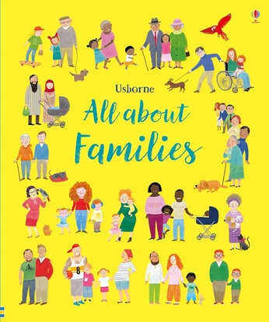  All About Families  The Journey Home | 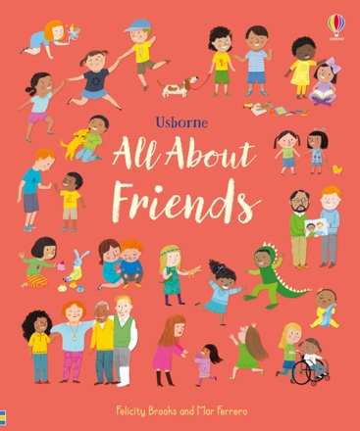  All About Friends | 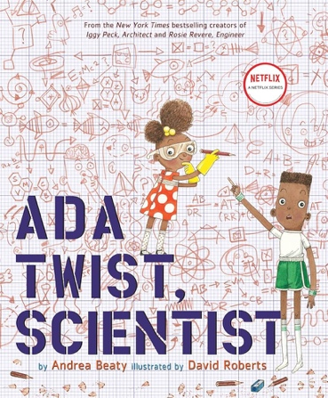  Ada Twist Scientist |  |  |  | 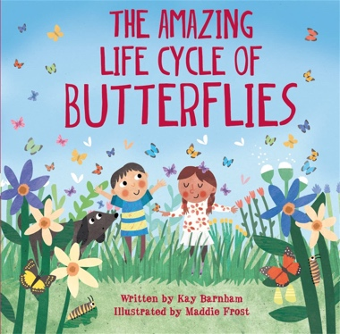  The Amazing Lifecycles of butterflies |  | 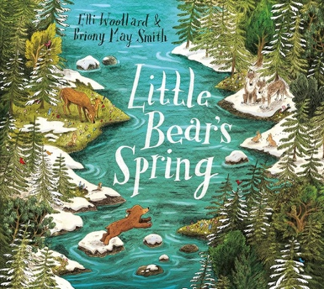  Little Bears Spring  The Farmyard | 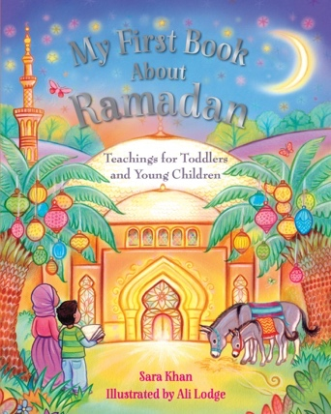  My First Book About Ramadan
WOW |  | Pancake making |  |  |  |  | Spring walk |  | Eid celebrations  Mother’s Day celebrations | Easter Egg hunt
Songs and Rhymes | Daffodils  Days of the week  Months of the year | Little Bo-Peep  Days of the week  Months of the year | Ladybird, Ladybird  Days of the week  Months of the year |  |  |  | 5 Little ducks went swimming one day.  Days of the week  Months of the year |  | Mary Had a Little Lamb  Days of the week  Months of the year | It’s Raining, It’s Pouring  Days of the week  Months of the year
C&L | NURSERY: 3-4 development matters  - Enjoy listening to longer stories and can remember much of what happens.  - Pay attention to more than one thing at a time, which can be difficult.  - Use a wider range of vocabulary.  - Understand a question or instruction that has two parts, such as: “Get your coat and wait at the door”.  - Understand ‘why’ questions, like: “Why do you think the gingerbread man ran away?”  - Sing a large repertoire of songs.  - Know many rhymes, be able to talk about familiar books, and be able to tell a long story.  - Develop their communication but may continue to have problems with irregular tenses and plurals, such as ‘runned’ for ‘ran’, ‘swimmed’ for ‘swam’.  - Develop their pronunciation but may have problems saying some sounds: r, j, th, ch, and sh.  - Use longer sentences of four to six words.  - Be able to express a point of view and to debate when they disagree with an adult or a friend, using words as well as actions.  - Start a conversation with an adult or a friend and continue it for many turns.  - Use talk to organise themselves and their play: “Let’s go on a bus... you sit there... I’ll be the driver.” |  |  |  |  | RECEPTION: Development matters reception  - Understand how to listen carefully and why listening is important.  - Learn new vocabulary.  - Use new vocabulary throughout the day.  - Ask questions to find out more and to check they understand what has been said to them.  - Articulate their ideas and thoughts in well-formed sentences.  - Connect one idea or action to another using a range of connectives.  - Describe events in some detail.  - Use talk to help work out problems and organise thinking and activities, and to explain how things work and why they might happen.  - Develop social phrases.  - Engage in story times.  - Listen to and talk about stories to build familiarity and understanding.  - Retell the story, once they have developed a deep familiarity with the text, some as exact repetition and some in their own words.  - Use new vocabulary in different contexts.  - Listen carefully to rhymes and songs paying attention to how they sound.  - Learn rhymes, poems, and songs.  - Engage in non-fiction books.  - Listen to and talk about selected non-fiction to develop deep familiarity, new knowledge, and vocabulary
Key Vocab | - Families  - Celebrating  - Tradition  - Fairy tales  - Author  - Science  - Investigate  - Explore  - Spring  - Seasons  - Lifecycles  - Easter  - Christianity  - Ramadan  - Islam / Muslim
Ideas | - Explore the vocabulary in our PTW texts.  - Explore rhyme in our PTP texts.  - Lots of book talk around focused text.  - PSED songs  - Retell The Journey Home  - Change the story of The Journey Home slightly.  - Talk about exciting experiences e.g., butterflies and chicks in classroom.  - Pull key vocabulary from texts.  - Looks at spring and talk about the changes the children have noticed.  - Lifecycles books  - Daily story time  - Weekly rhyme time  - Sequence and retell using story map, story spoons and sequencing pictures.  - Explore Fairy tales and retell their favourite tales.  - Can they come up with their own fairy tale and tell it to the class?  I will be learning to retell the story of The Journey Home.  I will be learning to change the story of The Journey Home slightly and make it my own.  I will be learning to talk about exciting experiences.  I will be learning to pull key vocabulary from texts to help with understanding.  I will be learning to observe and talk about the changes in spring that I have noticed.  I will be learning about lifecycles through books and discussions.  I will be learning to listen and engage with daily story time.  I will be learning to explore fairy tales and retell my favourite ones.  I will be learning to create my own fairy tale and tell it to the class.
PSED | NURSERY: 3-4 development matters  - Select and use activities and resources, with help when needed. This helps them to achieve a goal they have chosen, or one which is suggested to them.  - Develop their sense of responsibility and membership of a community.  - Become more outgoing with unfamiliar people, in the safe context of their setting.  - Show more confidence in new social situations.  - Play with one or more other children, extending and elaborating play ideas.  - Find solutions to conflicts and rivalries.  - Increasingly follow rules, understanding why they are important.  - Remember rules without needing an adult to remind them.  - Develop appropriate ways of being assertive. Talk with others to solve conflicts.  - Talk about their feelings using words like ‘happy’, ‘sad’, ‘angry’ or ‘worried’.  - Understand gradually how others might be feeling. |  |  |  |  | RECEPTION: Development matters reception  - See themselves as a valuable individual.  - Build constructive and respectful relationships.  - Express their feelings and consider the feelings of others.  - Show resilience and perseverance in the face of a challenge.  - Identify and moderate their own feelings socially and emotionally.  - Think about the perspective of others.  - Manage their own needs – personal hygiene.  - Know and talk about the different factors that support their overall health and wellbeing.  - JIGSAW – BEING ME IN MY WORLD
Ideas | - Tidy up songs and routines.  - Tidy up areas.  - Pictures resources  - Talk about why we shouldn’t tell lies.  - How are the characters feeling in the Journey Home?  - Continue to develop self-regulation techniques / mindfulness.  - Role play / social stories on solving conflicts and rivalries.  - Weekly Jigsaw PSHE sessions  - Look at hygiene and why it is important that we keep clean.  - Hand washing activity – water, pepper/glitter and washing up liquid.  - Teeth brushing – visit from dentist.  I will be learning to follow tidy up songs and routines to help keep our classroom organized.  I will be learning to tidy up different areas in the classroom and take responsibility for my space.  I will be learning to use pictures and resources to help me with my learning and activities.  I will be learning to talk about why we shouldn’t tell lies and understand the importance of honesty.  I will be learning to think about how the characters are feeling in The Journey Home and why they feel that way.  I will be learning to continue developing self-regulation techniques, including mindfulness, to help me manage my emotions.  I will be learning to role-play and use social stories to solve conflicts and manage rivalries with my friends.  I will be learning to participate in weekly Jigsaw PSHE sessions to develop my understanding of feelings and friendships.  I will be learning to explore hygiene and understand why it is important to keep ourselves clean.  I will be learning to practice hand washing through an activity with water, pepper/glitter, and washing-up liquid.  I will be learning about teeth brushing through a visit from the dentist and practicing good oral hygiene.
Physical | NURSERY: 3-4 development matters  - Continue to develop their movement, balancing, riding and ball skills.  - Go up steps and stairs, or climb up apparatus, using alternate feet.  - Skip, hop, stand on one leg, and hold a pose for a game like musical statues.  - Use large-muscle movements to wave flags and streamers, paint and make marks.  - Start taking part in some group activities which they make up for themselves, or in teams.  - Increasingly be able to use and remember sequences and patterns of movements which are related to music and rhythm.  - Match their developing physical skills to tasks and activities in the setting. For example, they decide whether to crawl, walk or run across a plank, depending on its length and width.  - Choose the right resources to carry out their own plan. For example, choosing a spade to enlarge a small hole they dug with a trowel.  - Collaborate with others to manage large items, such as moving a long plank safely, carrying large hollow blocks.  - Use one-handed tools and equipment, for example, making snips in paper with scissors.  - Use a comfortable grip with good control when holding pens and pencils.  - Show a preference for a dominant hand.  - Be increasingly independent as they get dressed and undressed, for example, putting coats on and doing up zips. |  |  |  |  | RECEPTION: Development matters reception  - Revise and refine the fundamental movement skills they have already acquired: rolling, crawling, walking, jumping, running, hopping, skipping, climbing.  - Progress towards a more fluent style of moving, with developing control and grace.  - Develop the overall body strength, co-ordination, balance, and agility needed to engage successfully with future physical education sessions.  - Develop their small motor skills so that they can use a range of tools competently, safely, and confidently.  - Use their core muscle strength to achieve a good posture when sitting at a table or sitting on the floor.  - Combine different movements with ease and fluency.  - Confidently and safely use a range of large and small apparatus indoors and outside, alone and in a group.  - Develop overall body-strength, balance, co-ordination, and agility.  - Further develop and refine a range of ball skills.  - Develop confidence, competence, precision, and accuracy when engaging in activities that involve a ball.  - Further develop and refine a range of ball skills including throwing, catching, kicking, passing, batting, and aiming.  - Develop confidence, competence, precision, and accuracy when engaging in activities that involve a ball.  - Further develop the skills they need to manage the school day successfully: lining up/ queuing/ mealtimes  - GET SET 4 PE – INTRODUCTION TO PE
Ideas | - Name writing  - Story map for The Journey Home  - Exploring how things work  - Construct using small manipulatives e.g., Lego.  - Build a fairy tale castle.  - Drawing lifecycles – observations of class guests  - Weekly PE  - Squiggle while you wiggle.  - Dough discoes  Fine motor in CP.  - Fine motor challenges  - Name writing  - Spring observational drawings  I will be learning to write my name using correct pencil grip.  I will be learning to construct with small manipulatives, like Lego, to create my own designs and structures.  I will be learning to build a fairy tale castle, using my imagination and construction skills.  I will be learning to draw lifecycles through observations of class guests, like caterpillars or chicks.  I will be learning to participate in weekly PE sessions to improve my physical coordination and movement.  I will be learning to enjoy Squiggle While You Wiggle to develop my fine motor skills through fun movement activities.  I will be learning to participate in Dough Disco to strengthen my hand muscles and improve my writing skills.  I will be learning to complete fine motor challenges in the continuous provision to develop my hand-eye coordination.  I will be learning to improve my fine motor skills through name writing and other related activities.  I will be learning to create spring observational drawings, paying attention to details in nature, like flowers and trees.
Maths | NURSERY: 3-4 development matters  - Develop fast recognition of up to 3 objects, without having to count them individually (‘subitising’).  - Recite numbers past 5.  - Say one number for each item in order: 1,2,3,4,5.  - Know that the last number reached when counting a small set of objects tells you how many there are in total.  - Show ‘finger numbers’ up to 5.  - Link numerals and amounts: for example, showing the right number of objects to match the numeral, up to 5.  - Experiment with their own symbols and marks as well as numerals.  - Solve real world mathematical problems with numbers up to 5.  - Compare quantities using language: ‘more than’, ‘fewer than’.  - Talk about and explore 2D and 3D shapes.  - Understand position through words alone!  - Describe a familiar route.  - Discuss routes and locations, using words like ‘in front of’ and ‘behind’.  - Make comparisons between objects relating to size, length, weight, and capacity.  - Combine shapes to make new ones – an arch, a bigger triangle, etc.  - Talk about and identify the patterns around them.  - Extend and create ABAB patterns.  - Notice and correct an error in a repeating pattern.  - Begin to describe a sequence of events, real or fictional, using words such as ‘first’, ‘then...’ |  |  |  |  |  |  | RECEPTION: Development matters reception  - Count objects, actions, and sounds.  - Subitise.  - Link the number symbol (numeral) with its cardinal number value.  - Count beyond ten.  - Compare numbers.  - Understand the ‘one more than/one less than’ relationship between consecutive numbers.  - Explore the composition of numbers to 10.  - Automatically recall number bonds for numbers 0–5 and some to 10.  - Select, rotate, and manipulate shapes to develop spatial reasoning skills.  - Compose and decompose shapes so that children recognise a shape can have other shapes within it, just as numbers can.  - Continue, copy, and create repeating patterns.  - Compare length, weight, and capacity.
Key Vocab | - Counting  - Larger sets  - Actions and sounds.  - Subitising  - Sets  - 10-frame  - Doubles  - Rekenrek  - More / Less  - Magnitude  - Quantities  - One more than / One less than  - Ordering numbers  - Staircase pattern  - Odd numbers  - Even numbers  - Attributes  - Focus on 7  - Doubles  - Sorting
Ideas | Pupils will consolidate their counting skills, counting to larger numbers and developing a wider range of counting strategies. They will secure knowledge of number facts through varied practice.  Pupils will:  - continue to develop their counting skills, counting larger sets as well as counting actions and sounds.  - explore a range of representations of numbers, including the 10-frame, and see how doubles can be arranged in a 10-frame.  - compare quantities and numbers, including sets of objects which have different attributes.  - continue to develop a sense of magnitude, e.g., knowing that 8 is quite a lot more than 2, but 4 is only a little bit more than 2.  - begin to generalise about ‘one more than’ and ‘one less than’ numbers within 10.  - continue to identify when sets can be subitised and when counting is necessary.  - develop conceptual subitising skills including when using a rekenrek.  - Focus on the ‘staircase’ pattern and ordering numbers.  - Focus on ordering of numbers to 8.  - Use language of less than  - Focus on 7  - Doubles – explore how some numbers can be made with 2 equal parts.  - Sorting numbers according to attributes - odd and even numbers  I will be learning to consolidate my counting skills by counting larger sets and counting actions and sounds.  I will be learning to explore a range of representations of numbers, including using the 10-frame to understand numbers better.  I will be learning to see how doubles can be arranged in a 10-frame and use this to help with counting.  I will be learning to generalise about ‘one more than’ and ‘one less than’ numbers within 10.  I will be learning to identify when I can subitise (recognize a number without counting) and when I need to count.  I will be learning to develop my conceptual subitising skills, especially when using a rekenrek.  I will be learning to order numbers to 8 and understand their sequence.  I will be learning to focus on the number 7 and explore its properties.  I will be learning to explore doubles and see how some numbers can be made with 2 equal parts.  I will be learning to sort numbers according to their attributes, such as identifying odd and even numbers.
Literacy | NURSERY: 3-4 development matters  - Understand the five key concepts about print:  - print has meaning.  - print can have different purposes.  - we read English text from left to right and from top to bottom.  - the names of the different parts of a book  - page sequencing  - Develop their phonological awareness, so that they can:  - spot and suggest rhymes.  - count or clap syllables in a word.  - recognise words with the same initial sound, such as money and mother.  - Engage in extended conversations about stories, learning new vocabulary.  - Use some of their print and letter knowledge in their early writing.  - Write some or all their name.  - Write some letters accurately. |  |  |  |  | RECEPTION: Development matters reception  - Read individual letters by saying the sounds for them.  - Blend sounds into words, so that they can read short words made up of known letter-sound correspondences.  - Read some letter groups that each represent one sound and say sounds for them.  - Read a few common exception words matched to the school’s phonic programme.  - Read simple phrases and sentences made up of words with known letter–sound correspondences and, where necessary, a few exception words.  - Re-read these books to build up their confidence in word reading, their fluency and their understanding and enjoyment.  - Form lower-case and capital letters correctly.  - Spell words by identifying the sounds and then writing the sound with letter/s.  - Write short sentences with words with known sound-letter correspondences using a capital letter and full stop.  - Re-read what they have written to check that it makes sense.
Key Vocab | - Families  - Celebrating  - Tradition  - Fairy tales  - Author  - Science  - Investigate  - Explore  - Spring  - Seasons  - Lifecycles  - Easter  - Christianity  - Ramadan  - Islam / Muslim  - Author  - Title  - Blurb  - Characters  - Plot  - Illustrations  - Beginning  - Middle  - End
Ideas | - Daily story times looking at the author, titles, and blurbs.  - RWInc lessons  - PTW lessons  - PTP lessons  - Pinny time  - Red word challenges  - Roll, read and write in the writing areas.  - Read longer words such as crab.  - Read simple sentences related to familiar texts.  - Farm related books  - Books about different types of lifecycles  - Lots of science books and books about famous scientists  - Traditional tales and Fairy tales – can they write their own fairy tale.  - Writing instructions about how things work  - Daily fine motor activities  I will be learning to explore daily story times by looking at the author, titles, and blurbs.  I will be learning to enjoy Pinny time and practice my letter formation and writing.  I will be learning to challenge myself with red word challenges to improve my sight word recognition.  I will be learning to roll, read, and write in the writing areas to strengthen my literacy skills.  I will be learning to read longer words, such as 'crab', and break them down into smaller parts.  I will be learning to read simple sentences related to familiar texts to build my confidence in reading.  I will be learning to explore farm-related books to discover more about farm animals and life on the farm.  I will be learning about different types of lifecycles through books and discussions.  I will be learning to read science books and learn about famous scientists and their discoveries.  I will be learning to explore traditional tales and fairy tales and try writing my own fairy tale.
UW | NURSERY: 3-4 development matters  - Use all their senses in hands-on exploration of natural materials.  - Explore collections of materials with similar and/or different properties  - Talk about what they see, using a wide vocabulary.  - Begin to make sense of their own life-story and family’s history.  - Show interest in different occupations.  - Explore how things work.  - Plant seeds and care for growing plants.  - Understand the key features of the life cycle of a plant and an animal.  - Begin to understand the need to respect and care for the natural environment and all living things.  - Talk about the differences between materials and changes they notice.  - Explore and talk about different forces they can feel.  - Continue developing positive attitudes about the differences between people.  - Know that there are different countries in the world and talk about the difference they have experienced or seen in photos. |  |  |  | RECEPTION: Development matters reception  - Talk about members of their family and community.  - Name and describe people who are familiar to them.  - Comment on images of familiar situations in the past.  - Compare and contrast characters from stories, including figures from the past.  - Draw information from a simple map.  - Understand that some places are special to members of their community.  - Recognise that people have different beliefs and celebrate special times in different ways.  - Recognise some similarities and differences between life in this country and life in  - other countries.  - Explore the natural world around them.  - Describe what they see, hear, and feel whilst outside.  - Understand the effect of changing seasons on the natural world around them.  - Recognise some environments that are different from the one in which they live.  - Describe that they see, feel, and hear whilst outside.
Ideas | - Pancake making in playdough – push and pull.  - Butterflies in class? Lifecycles  - St Patricks Day Celebrations  - Look at Irish traditions and culture.  - Spring walks  - Planting sunflowers  - Retell the Hungry Caterpillar  - Look at animals from different countries and their habitats.  - Observational drawings of trees / different plants  - Explore lifecycles.  - Easter celebrations  - Ramadan celebrations  - Chicks  - Look at the celebration of Eid and any children in our school/class who celebrate it.  I will be learning to explore pancake making in playdough by using push and pull actions.  I will be learning about lifecycles, especially focusing on butterflies in class.  I will be learning to celebrate St. Patrick's Day and explore its traditions and customs.  I will be learning to observe and enjoy the changes of spring during our spring walks.  I will be learning to look at animals from different countries and understand their habitats.  I will be learning to make observational drawings of trees and different plants to see their details.  I will be learning to explore and understand lifecycles through hands-on activities.  I will be learning to celebrate Easter and explore its traditions.  I will be learning about the celebration of Ramadan and the customs associated with it.  I will be learning to explore and understand the celebration of Eid and how some children in our class celebrate it.
E&D | NURSERY: 3-4 development matters  - Take part in simple pretend play.  - Begin to develop complex stories using small world equipment.  - Explore different materials freely, to develop their ideas about how to use them and what to make.  - Develop their own ideas and then decide which materials to use to express them.  - Join different materials and explore different textures.  - Create closed shapes with continuous lines and begin to use these shapes to represent objects.  - Draw with increasing complexity and detail, such as representing a face with a circle and including details.  - Use drawing to represent ideas like movement or loud noises.  - Show different emotions in their drawings and paintings.  - Explore colour and colour mixing.  - Listen with increased attention to sounds: Respond to what they have heard, expressing their thoughts and feelings.  - Remember and sing entire songs.  - Sing the pitch of a tone sung by another person.  - Sing the melodic shape of familiar songs.  - Create their own songs or improvise a song around one they know.  - Play instruments with increasing control to express their feelings and ideas. |  |  |  |  | RECEPTION: Development matters reception  - Explore, use, and refine a variety of artistic effects to express their ideas and feelings.  - Return to and build on their previous learning, refining ideas and developing their ability to represent them.  - Create collaboratively, sharing ideas, resources, and skills.  - Listen attentively, move to, and talk about music, expressing their feelings and responses.  - Watch and talk about dance and performance art, expressing their feelings and responses.  - Sing in a group or on their own, increasingly matching the pitch and following the melody.  - Develop storylines in their pretend play.
Ideas | - Construct animal habitats – bug hotel  - Small world (mini beasts)  - Small world – lifecycles  - Painting flowers  - Butterfly painting  - Nursery rhymes  - Create an Easter Egg collage.  - Observational drawings – caterpillars / chicks  I will be learning to construct animal habitats, like a bug hotel, using a variety of materials.  I will be learning to explore small world play with mini beasts and create imaginative scenarios.  I will be learning to use small world play to explore lifecycles and understand how creatures grow and change.  I will be learning to paint flowers and explore different colours and brush techniques.  I will be learning to create a butterfly painting, using bright colours to represent its wings.  I will be learning to sing nursery rhymes and explore rhythm and melody through music.  I will be learning to create an Easter egg collage, using different materials and textures to make it unique.  I will be learning to make observational drawings of caterpillars and chicks, focusing on their details and features.
KS1  Curriculum Links | - Islam  - Christianity  - Famous Scientists  - Sculpture- Andy Goldsmith  - Travel and Exploration
Home Learning | Weekly maths  Weekly phonics (reception)  Weekly reading  Weekly curriculum | Weekly maths  Weekly phonics (reception)  Weekly reading  Weekly curriculum | Weekly maths  Weekly phonics (reception)  Weekly reading  Weekly curriculum | Weekly maths  Weekly phonics (reception)  Weekly reading  Weekly curriculum |  |  | Weekly maths  Weekly phonics (reception)  Weekly reading  Weekly curriculum |  | Weekly maths  Weekly phonics (reception)  Weekly reading  Weekly curriculum | Weekly maths  Weekly phonics (reception)  Weekly reading  Weekly curriculum

