EYFS Curriculum Autumn 1: 2024/2025
NURSERY RECEPTION
W/C | Week 1 | Week 2 | Week 3 | Week 4 |  |  | Week 5 |  | Week 6 | Week 7 | Week 8
Key Dates |  | 13th September – Roald Dahl Day | 22nd September – Autumn Equinox | 22nd September – Autumn Equinox |  |  | 1st October – Harvest Festival  4th October – World Space Week |  | 10th October – World Mental Health Day | 16th October – World Recycling Day | 25th October – International Artists Day  31st October – Halloween
Themes | Marvellous Me:  - W1: All about me  - WK2: What is important to me.  - WK3: Where I live.  - WK4: My superpowers |  |  |  |  |  | Autumn Days  - WK5: Harvest  - WK6: Woodland Animals  - WK7: Art Focus (autumn)  - WK8: Halloween
Texts | When a Dragon Goes to School  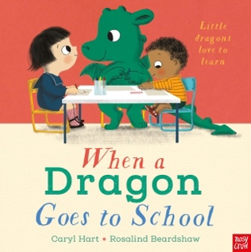 | The Gingerbread Man (Pathways to Write)  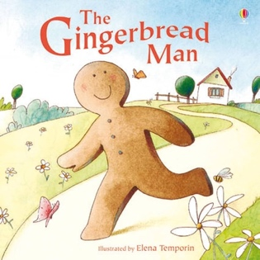 | Me on the Map!  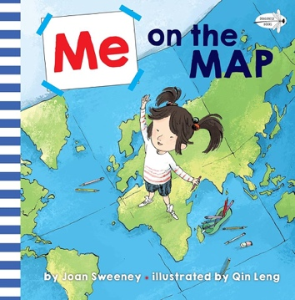 | Supertato  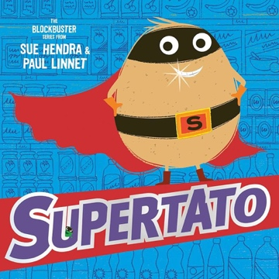 |  |  | A Bundel of Rhymes by Mother Goose (Pathways to Poetry)  Hello Autumn.  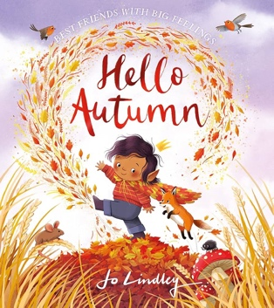 |  | The Leaf Thief  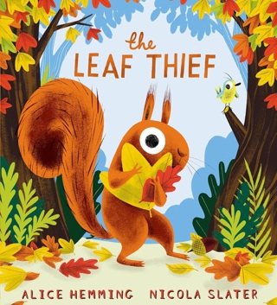 | Mixed  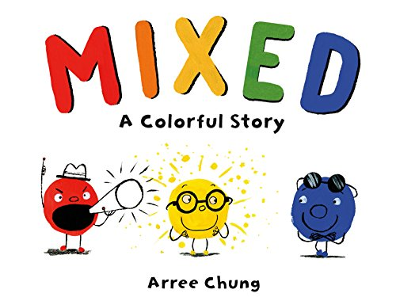 | Room on the Broom  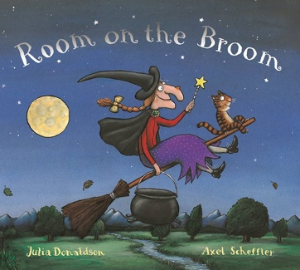
WOW |  | Tea Party (Bring something important to you to our tea party) | Walk around local area | Superpower celebration parade |  |  | Harvest – harvest veg from planting beds |  | Autumn Walk | Art focus | Halloween Party
Songs and Rhymes | Days of the week  Months of the year  Heads, Shoulders, Knees, and Toes | Days of the week  Months of the year  I am The Baker Man | Days of the week  Months of the year  Five Little Speckled Frogs | Days of the week  Months of the year  Five Little Men in a Flying Saucer |  |  | Days of the week  Months of the year  Oats and Beans and Barley |  | Days of the week  Months of the year  Teddy Bears Picnic | Days of the week  Months of the year  Mixing Colours Song | Days of the week  Months of the year  Six Little Ghosts
C&L | NURSERY: 3-4 development matters  - Enjoy listening to longer stories and can remember much of what happens.  - Pay attention to more than one thing at a time, which can be difficult.  - Use a wider range of vocabulary.  - Understand a question or instruction that has two parts, such as: “Get your coat and wait at the door”.  - Understand ‘why’ questions, like: “Why do you think the gingerbread man ran away?”  - Sing a large repertoire of songs.  - Know many rhymes, be able to talk about familiar books, and be able to tell a long story.  - Develop their communication but may continue to have problems with irregular tenses and plurals, such as ‘runned’ for ‘ran’, ‘swimmed’ for ‘swam’.  - Develop their pronunciation but may have problems saying some sounds: r, j, th, ch, and sh.  - Use longer sentences of four to six words.  - Be able to express a point of view and to debate when they disagree with an adult or a friend, using words as well as actions.  - Start a conversation with an adult or a friend and continue it for many turns.  - Use talk to organise themselves and their play: “Let’s go on a bus... you sit there... I’ll be the driver.” |  |  |  |  | RECEPTION: Development matters reception  - Understand how to listen carefully and why listening is important.  - Learn new vocabulary.  - Use new vocabulary throughout the day.  - Ask questions to find out more and to check they understand what has been said to them.  - Articulate their ideas and thoughts in well-formed sentences.  - Connect one idea or action to another using a range of connectives.  - Describe events in some detail.  - Use talk to help work out problems and organise thinking and activities, and to explain how things work and why they might happen.  - Develop social phrases.  - Engage in story times.  - Listen to and talk about stories to build familiarity and understanding.  - Retell the story, once they have developed a deep familiarity with the text, some as exact repetition and some in their own words.  - Use new vocabulary in different contexts.  - Listen carefully to rhymes and songs paying attention to how they sound.  - Learn rhymes, poems, and songs.  - Engage in non-fiction books.  - Listen to and talk about selected non-fiction to develop deep familiarity, new knowledge, and vocabulary
Key Vocab | - Kindness  - Integrity  - Tenacity  - Me  - Family  - Home  - Unique  - Special  - Individual  - England  - Runcorn  - Local  - Town  - Country  - Castlefield’s |  |  |  |  |  | - Kindness/Integrity/Tenacity  - Harvest, festival, vegetables, fruits, scarecrows, combine harvester, sowing seeds, growing. Autumn, leaves, conkers, orange, brown, yellow, red, seasons, rustling, crunchy, autumn weather.  - Woodland  - Fox  - Hare  - Deep  - Rabbit  - Squirrel  - Hedgehog  - Trees  - Berries  - Acorn  - Halloween  - Witch  - Ghost  - Tradition  - Celebration  - Primary colours/ Secondary colours  - Red/Yellow/Blue/Green/Orange/Purple  - Mix  - Artist  - Art
Ideas | - Reading and talking about the vocabulary in different texts  - Rhyme time daily  - Weather songs  - Home corner role play  - Family pictures in home corner  - Explore rhyme in our PTP texts.  - Local shop – role play (shopping city?)  - Explore the vocabulary in our PTW texts.  - Investigate different vegetables.  - Explore how different vegetables grow.  - Introduce new vocabulary linked to seasons.  - Autumn themed small world  - Vegetable patch in the mud kitchen – harvest link  I will be learning to talk about myself using describing words such as tall, short.  I will be imagining and recreating roles in real life family situations and fictional stories.  I will be asking questions to get to know my friends in my new class.  I will be talking about my family.  I will be thinking about sequence of events in stories and saying what happened in the beginning, middle and end.  I will be discussing the weather and days of the week
PSED | NURSERY: 3-4 development matters  - Select and use activities and resources, with help when needed. This helps them to achieve a goal they have chosen, or one which is suggested to them.  - Develop their sense of responsibility and membership of a community.  - Become more outgoing with unfamiliar people, in the safe context of their setting.  - Show more confidence in new social situations.  - Play with one or more other children, extending and elaborating play ideas.  - Find solutions to conflicts and rivalries.  - Increasingly follow rules, understanding why they are important.  - Remember rules without needing an adult to remind them.  - Develop appropriate ways of being assertive. Talk with others to solve conflicts.  - Talk about their feelings using words like ‘happy’, ‘sad’, ‘angry’ or ‘worried’.  - Understand gradually how others might be feeling. |  |  |  |  | RECEPTION: Development matters reception  - See themselves as a valuable individual.  - Build constructive and respectful relationships.  - Express their feelings and consider the feelings of others.  - Show resilience and perseverance in the face of a challenge.  - Identify and moderate their own feelings socially and emotionally.  - Think about the perspective of others.  - Manage their own needs – personal hygiene.  - Know and talk about the different factors that support their overall health and wellbeing.  - JIGSAW – BEING ME IN MY WORLD
Ideas | - Family pictures  - Transition sessions  - Visual timetables  - Circle time  - Tidy up songs and areas.  - Class charter  - Exploring feelings in the characters of a text  - Class jobs  - Feelings chart – linked to the colour monster.  - Weekly Jigsaw PSHE  - The Colour Monster Goes to School  I will be learning the classroom routine.  I will be creating class rules with my friends.  I will be participating in turn taking games.  I will be trying out new activities independently and select resources independently.  I will be learning routines of the school day.  I will be learning to think about the feelings of others.  I will be learning and talking about my family and other people who are important to me.
Physical | NURSERY: 3-4 development matters  - Continue to develop their movement, balancing, riding and ball skills.  - Go up steps and stairs, or climb up apparatus, using alternate feet.  - Skip, hop, stand on one leg, and hold a pose for a game like musical statues.  - Use large-muscle movements to wave flags and streamers, paint and make marks.  - Start taking part in some group activities which they make up for themselves, or in teams.  - Increasingly be able to use and remember sequences and patterns of movements which are related to music and rhythm.  - Match their developing physical skills to tasks and activities in the setting. For example, they decide whether to crawl, walk or run across a plank, depending on its length and width.  - Choose the right resources to carry out their own plan. For example, choosing a spade to enlarge a small hole they dug with a trowel.  - Collaborate with others to manage large items, such as moving a long plank safely, carrying large hollow blocks.  - Use one-handed tools and equipment, for example, making snips in paper with scissors.  - Use a comfortable grip with good control when holding pens and pencils.  - Show a preference for a dominant hand.  - Be increasingly independent as they get dressed and undressed, for example, putting coats on and doing up zips. |  |  |  |  | RECEPTION: Development matters reception  - Revise and refine the fundamental movement skills they have already acquired: rolling, crawling, walking, jumping, running, hopping, skipping, climbing.  - Progress towards a more fluent style of moving, with developing control and grace.  - Develop the overall body strength, co-ordination, balance, and agility needed to engage successfully with future physical education sessions.  - Develop their small motor skills so that they can use a range of tools competently, safely, and confidently.  - Use their core muscle strength to achieve a good posture when sitting at a table or sitting on the floor.  - Combine different movements with ease and fluency.  - Confidently and safely use a range of large and small apparatus indoors and outside, alone and in a group.  - Develop overall body-strength, balance, co-ordination, and agility.  - Further develop and refine a range of ball skills.  - Develop confidence, competence, precision, and accuracy when engaging in activities that involve a ball.  - Further develop and refine a range of ball skills including throwing, catching, kicking, passing, batting, and aiming.  - Develop confidence, competence, precision, and accuracy when engaging in activities that involve a ball.  - Further develop the skills they need to manage the school day successfully: lining up/ queuing/ mealtimes  - GET SET 4 PE – INTRODUCTION TO PE
Ideas | - Streamers in the wind – building gross motor.  - Squiggle while you wiggle.  - Large paper on floor – large muscle movements  - CP independent choices in creative area  - Play dough tools  - Weekly PE sessions  - Draw and paint – Autumn observations, self-portraits.  - Pulling and pushing vegetables in the vegetable patch – harvest  - Drawing vegetables – observations  - Chopping vegetables  I will be playing a variety of games.  I will be using tools safely.  I will be learning about how to be healthy.  I will be describing the changes my body after being active.  I will be moving with control and co-ordination over, under, through various small apparatus.  I will be using a range of small and large equipment.  I will be using a range of malleable materials in my play.
Maths | NURSERY: 3-4 development matters  - Develop fast recognition of up to 3 objects, without having to count them individually (‘subitising’).  - Recite numbers past 5.  - Say one number for each item in order: 1,2,3,4,5.  - Know that the last number reached when counting a small set of objects tells you how many there are in total.  - Show ‘finger numbers’ up to 5.  - Link numerals and amounts: for example, showing the right number of objects to match the numeral, up to 5.  - Experiment with their own symbols and marks as well as numerals.  - Solve real world mathematical problems with numbers up to 5.  - Compare quantities using language: ‘more than’, ‘fewer than’.  - Talk about and explore 2D and 3D shapes.  - Understand position through words alone!  - Describe a familiar route.  - Discuss routes and locations, using words like ‘in front of’ and ‘behind’.  - Make comparisons between objects relating to size, length, weight, and capacity.  - Combine shapes to make new ones – an arch, a bigger triangle, etc.  - Talk about and identify the patterns around them.  - Extend and create ABAB patterns.  - Notice and correct an error in a repeating pattern.  - Begin to describe a sequence of events, real or fictional, using words such as ‘first’, ‘then...’ |  |  |  |  |  |  | RECEPTION: Development matters reception  - Count objects, actions, and sounds.  - Subitise.  - Link the number symbol (numeral) with its cardinal number value.  - Count beyond ten.  - Compare numbers.  - Understand the ‘one more than/one less than’ relationship between consecutive numbers.  - Explore the composition of numbers to 10.  - Automatically recall number bonds for numbers 0–5 and some to 10.  - Select, rotate, and manipulate shapes to develop spatial reasoning skills.  - Compose and decompose shapes so that children recognise a shape can have other shapes within it, just as numbers can.  - Continue, copy, and create repeating patterns.  - Compare length, weight, and capacity.
Key Vocab | - Count  - Number  - Total  - Same/Different  - Pair  - Groups  - Square/triangle/circle/rectangle  - Shape/sides/corners  - Now and next  - Repeat  - Bigger/smaller  - Longer/shorter  - First/them/next
Ideas | - Baseline  - Counting/Number/Rhymes  - One  - Two  - Pairs  - Three  - Four  - Five  - Same and different  - Match and sort  - One more  - One less  - Time  Mathematical experiences  - Counting rhymes and songs- number songs of the week  - Exploring colours- matching  Matching activities  - Exploring and matching objects which are the same.  Sorting activities  - Sorting according to colour, shape, or size.  I will be completing my Baseline assessment.  I will be learning to match and sort.  I will be learning to compare amounts.  I will be learning to represent and compare numbers 1-5  I will be learning to compare size, mass, and capacity.
Literacy | NURSERY: 3-4 development matters  - Understand the five key concepts about print:  - print has meaning.  - print can have different purposes.  - we read English text from left to right and from top to bottom.  - the names of the different parts of a book  - page sequencing  - Develop their phonological awareness, so that they can:  - spot and suggest rhymes.  - count or clap syllables in a word.  - recognise words with the same initial sound, such as money and mother.  - Engage in extended conversations about stories, learning new vocabulary.  - Use some of their print and letter knowledge in their early writing.  - Write some or all their name.  - Write some letters accurately. |  |  |  |  | RECEPTION: Development matters reception  - Read individual letters by saying the sounds for them.  - Blend sounds into words, so that they can read short words made up of known letter-sound correspondences.  - Read some letter groups that each represent one sound and say sounds for them.  - Read a few common exception words matched to the school’s phonic programme.  - Read simple phrases and sentences made up of words with known letter–sound correspondences and, where necessary, a few exception words.  - Re-read these books to build up their confidence in word reading, their fluency and their understanding and enjoyment.  - Form lower-case and capital letters correctly.  - Spell words by identifying the sounds and then writing the sound with letter/s.  - Write short sentences with words with known sound-letter correspondences using a capital letter and full stop.  - Re-read what they have written to check that it makes sense.
Key Vocab | - Author  - Poet  - Blurb  - Rhyme  - Front cover  - Title  - Character  - Setting
Ideas | - Daily storytimes looking at authors, titles and blurbs  - Reading a wide range of texts about autumn, traditional tales and space.  - Look at rhymes in The Gingerbread Man e.g., man and ran.  - Non-fiction books on space  - Different types of texts around the classroom  - Labelling of resources  - Singing nursery rhymes daily and recognising rhyming words in the songs  - RWInc lessons  - PTW lessons  - PTP lessons  - Writing CVC words  - Fred Games  - Family books in reading area  - Daily fine motor activities to develop fine motor skills  Pinny time  I will be learning to recognise and write my name.  I will be learning to write familiar words such as mum, dad.  I will be writing about myself and my family.  I will be learning to write for a purpose e.g., making lists, labelling pictures.  I will be reading a range of fiction/non-fiction books·  I will be learning different sounds that letters make (phonics)  I will be learning to blend sounds together to make simple words.
UW | NURSERY: 3-4 development matters  - Use all their senses in hands-on exploration of natural materials.  - Explore collections of materials with similar and/or different properties  - Talk about what they see, using a wide vocabulary.  - Begin to make sense of their own life-story and family’s history.  - Show interest in different occupations.  - Explore how things work.  - Plant seeds and care for growing plants.  - Understand the key features of the life cycle of a plant and an animal.  - Begin to understand the need to respect and care for the natural environment and all living things.  - Talk about the differences between materials and changes they notice.  - Explore and talk about different forces they can feel.  - Continue developing positive attitudes about the differences between people.  - Know that there are different countries in the world and talk about the difference they have experienced or seen in photos. |  |  |  | RECEPTION: Development matters reception  - Talk about members of their family and community.  - Name and describe people who are familiar to them.  - Comment on images of familiar situations in the past.  - Compare and contrast characters from stories, including figures from the past.  - Draw information from a simple map.  - Understand that some places are special to members of their community.  - Recognise that people have different beliefs and celebrate special times in different ways.  - Recognise some similarities and differences between life in this country and life in other countries.  - Explore the natural world around them.  - Describe what they see, hear, and feel whilst outside.  - Understand the effect of changing seasons on the natural world around them.  - Recognise some environments that are different from the one in which they live.
Ideas | - Family pictures – displayed in the home corner  - Autumn walks  - Using a wide variety of texts  - Who lives in my house?  - Mud kitchen  - Loose parts  - Sound hunts  - Autumn Tuff Trays  - Pumpkin nail and hammer (FMS)  - Looking for animal habitats (owls)  - Plant vegetables and make vegetable soup  - Daily weather songs  I will be using all five senses to investigate area around them.  I will be recognising similarities and differences between each other.  I will be going on local walks around the school.  I will be learning about different traditions.  I will be exploring different season
E&D | NURSERY: 3-4 development matters  - Take part in simple pretend play.  - Begin to develop complex stories using small world equipment.  - Explore different materials freely, to develop their ideas about how to use them and what to make.  - Develop their own ideas and then decide which materials to use to express them.  - Join different materials and explore different textures.  - Create closed shapes with continuous lines and begin to use these shapes to represent objects.  - Draw with increasing complexity and detail, such as representing a face with a circle and including details.  - Use drawing to represent ideas like movement or loud noises.  - Show different emotions in their drawings and paintings.  - Explore colour and colour mixing.  - Listen with increased attention to sounds: Respond to what they have heard, expressing their thoughts and feelings.  - Remember and sing entire songs.  - Sing the pitch of a tone sung by another person.  - Sing the melodic shape of familiar songs.  - Create their own songs or improvise a song around one they know.  - Play instruments with increasing control to express their feelings and ideas. |  |  |  |  | RECEPTION: Development matters reception  - Explore, use, and refine a variety of artistic effects to express their ideas and feelings.  - Return to and build on their previous learning, refining ideas and developing their ability to represent them.  - Create collaboratively, sharing ideas, resources, and skills.  - Listen attentively, move to, and talk about music, expressing their feelings and responses.  - Watch and talk about dance and performance art, expressing their feelings and responses.  - Sing in a group or on their own, increasingly matching the pitch and following the melody.  - Develop storylines in their pretend play.
Ideas | - Drawing planets  - Musical instruments to represent space  - Autumn themed animals  - Small world – Bears / Forest animals  - Home corner  - Self portraits  - Daily rhymes  - Lots of opportunities to explore colour and colour mixing.  - Harvest – farmers market role play  I will be drawing/painting pictures of myself using mirrors.  I will be drawing pictures of my family.  I will be thinking about colours and using them appropriately in my pictures.  I will be using a range of objects to print with e.g., shoes, hands.  I will be learning new songs to help me in my learning.  I will be roleplaying in the home corner.  I will be acting out stories with puppets.  I will be using a range of materials to make collages and models.
KS1  Curriculum Links | - Living Things and their Habitats- Year 2  - My History: Me and my family. Changes in  - My Geography: Let’s Go Global. Where am I in the world?
Home Learning | Weekly maths  Weekly phonics (reception)  Weekly reading  Weekly curriculum | Weekly maths  Weekly phonics (reception)  Weekly reading  Weekly curriculum | Weekly maths  Weekly phonics (reception)  Weekly reading  Weekly curriculum | Weekly maths  Weekly phonics (reception)  Weekly reading  Weekly curriculum |  |  | Weekly maths  Weekly phonics (reception)  Weekly reading  Weekly curriculum |  | Weekly maths  Weekly phonics (reception)  Weekly reading  Weekly curriculum | Weekly maths  Weekly phonics (reception)  Weekly reading  Weekly curriculum | Weekly maths  Weekly phonics (reception)  Weekly reading  Weekly curriculum

