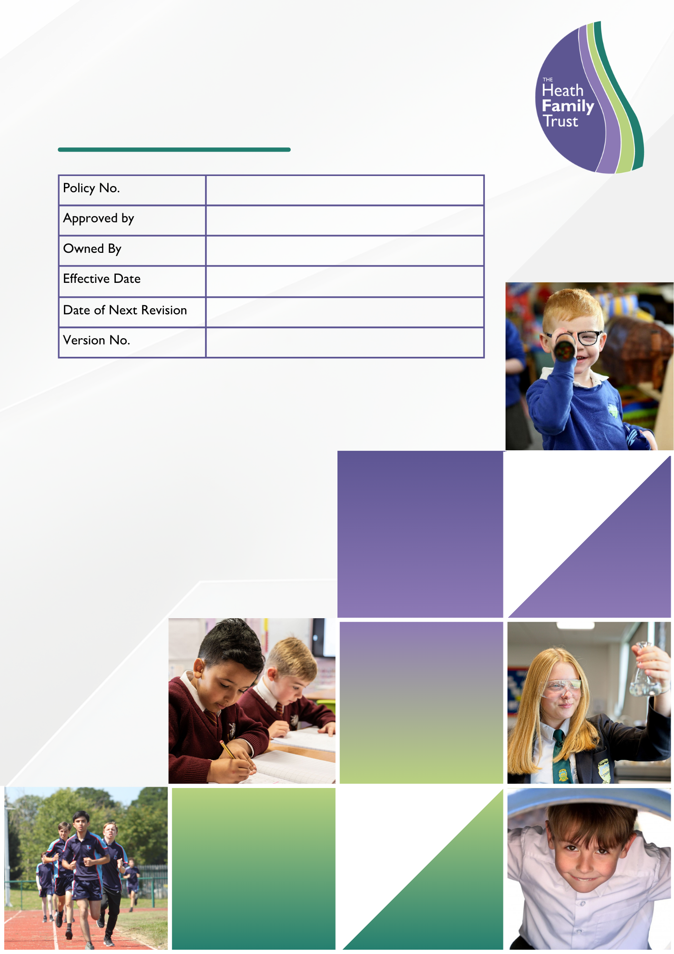
EQUALITY STATEMENT AND OBJECTIVES

CEO

October 2024
October 2028

Contents
1 Compliance 1
2 About this statement 1
3 Statement 1
4 Guiding principles 1
5 The curriculum 3
6 Ethos and organisation 4
7 Roles and responsibilities 4
8 Information and resources 5
9 Bridgewater Park’s Equality Objectives: 5
10 Policy access 5

Compliance

This equality statement and objectives has been prepared with due regard to the following statutory provisions and guidance:

Equality Act 2010;

Equality Act 2010 (Specific Duties and Public Authorities) Regulations 2017; and,

Equality and Human Rights Commission, “Technical guidance for schools in England” as updated July 2024.

Equality and Human Rights Commission, “Technical guidance on the public sector equality duty: England”, as updated 2023

About this statement

Bridgewater Park has developed this Equality Statement to help us to meet its Public Sector Equality Duty (PSED) under the Equality Act 2010.

The Equality Act’s provisions cover all aspects of school life such as the treatment of:

pupils and prospective and past pupils;

parents and carers;

employees; and,

the local community.

The act covers nine protected characteristics, which cannot be used as a reason to treat people unfairly. The protected characteristics are:

sex;

disability;

race;

age;

gender reassignment;

marriage and civil partnership;

pregnancy and maternity;

religion or belief; and,

sexual orientation.

The Equality Act makes it unlawful to treat someone differently, either through direct or indirect discrimination, harassment, and victimisation or by failing to make a reasonable adjustment for a disabled person.

Statement

Bridgewater Park is bound by the PSED to have due regard to the need to eliminate unlawful discrimination, harassment, and victimisation, and to promote equality of opportunity.

The specific duty on Bridgewater Park is to:

publish information to demonstrate how Bridgewater Park are complying with the PSED; and,

to prepare and publish equality objectives.

Guiding principles

In fulfilling the legal obligations cited above, Bridgewater Park are guided by the following principles:-

Principle 1: All pupils are of equal value

Bridgewater Park see all pupils and potential pupils, and their parents and carers, as of equal value:

whether or not they are disabled;

whether or not they are pregnant or away on maternity related absence;

whatever their ethnicity, culture, national origin or national status;

whatever their gender and gender identity;

whatever their religious or non-religious affiliation or faith background; and,

whatever their sexual identity.

Principle 2: Bridgewater Park recognises and respect difference

Treating people equally (Principle 1 above) does not necessarily involve treating them all the same. Bridgewater Park’s policies, procedures and activities must not discriminate but must nevertheless take account of differences of life-experience, outlook and background, and in the kinds of barriers and disadvantages which people may face, in relation to:

disability, so that reasonable adjustments are made;

ethnicity, so that different cultural backgrounds and experiences of prejudice are recognised;

gender and gender identity, so that the different needs and experiences of girls and boys, women and men, and those who have reassigned their gender are all recognised;

pregnancy and maternity, so that the differing needs of pregnant pupils and new mothers can be recognised;

religion, belief or faith background; or,

sexual identity.

Principle 3: Bridgewater Park fosters positive attitudes and relationships, and a shared sense of cohesion and belonging

Bridgewater Park intends that its policies, procedures and activities should promote:

positive attitudes towards disabled people, good relations between disabled and non-disabled people, and an absence of harassment of disabled people;

positive interaction, good relations and dialogue between groups and communities different from each other in terms of ethnicity, culture, religious affiliation, national origin or national status;

an absence of prejudice-related bullying and incidents, in particular concerning the protected characteristics;

positive attitudes towards pregnant pupils and new mothers;

mutual respect and good relations between boys and girls, women and men, and those who have reassigned their gender; and,

an absence of sexual and homophobic harassment.

Principle 4: Bridgewater Park observes good equalities practice in staff recruitment, retention and development

Bridgewater Park will not unjustifiably discriminate against our staff or applicants on the basis of their sex, marital or civil partner status, gender reassignment, sexual orientation, race, colour, nationality, ethnic or national origin, religion or belief, pregnancy or maternity, disability or age

Principle 5: Bridgewater Park aims to reduce and remove inequalities and barriers that already exist

In addition to avoiding or minimising possible negative impacts of Bridgewater Park policies, Bridgewater Park will take opportunities to maximise positive impacts by reducing and removing inequalities and barriers that may already exist between:

disabled and non-disabled people;

people of different ethnic, cultural and religious backgrounds; and

girls and boys, women and men.

Principle 6: Bridgewater Park consult and involve widely

Bridgewater Park engages with a range of groups and individuals to ensure that those who are affected by a policy or activity are consulted and involved in the design of new policies, and in the review of existing ones. Bridgewater Park consult and involve:

disabled people as well as non-disabled;

people from a range of ethnic, cultural and religious backgrounds;

women and men, girls and boys, and those who have reassigned their gender;

pregnant pupils and new mothers, and those with relevant experiences; and,

both women and men, and both girls and boys.

People of different sexual orientation [note this information may not be as readily available].

Principle 7: Bridgewater Park bases its policies and practices on sound evidence

Bridgewater Park maintains and publishes quantitative and qualitative information which shows its compliance with the public sector equality duty (PSED) set out in clause 149 of the Equality Act 2010, and on the basis of which Bridgewater Park decide on specific and measurable objectives.

Principle 8: Measurable objectives

Bridgewater Park formulates and publishes specific and measurable objectives, based on the consultations Bridgewater Park have conducted (principle 6) and the evidence Bridgewater Park have collected and published (principle 7). The objectives which Bridgewater Park identify take into account national and local priorities and issues, as appropriate. Bridgewater Park will keep its equality objectives under review and report annually on progress towards achieving them.

The curriculum

Bridgewater Park keeps each curriculum subject or area under review in order to ensure that teaching and learning reflect the principles set out above.

Ethos and organisation

Bridgewater Park is committed to ensuring that the principles listed above apply to the full range of its policies and practices, including those that are concerned with:

pupils' progress, attainment and achievement;

pupils' personal development, welfare and well-being;

teaching styles and strategies;

admissions and attendance;

staff recruitment, retention and professional development;

care, guidance and support;

behaviour, discipline and exclusions;

working in partnership with parents, carers and guardians;

working with the wider community; and,

addressing prejudice and prejudice-related bullying.

Bridgewater Park is opposed to all forms of prejudice which stand in the way of fulfilling its legal duties under the Equality Act for example:

prejudices around disability and special educational needs;

prejudices around racism and xenophobia, including those that are directed towards religious groups and communities, for example anti-Semitism and Islamophobia, and those that are directed against travellers, migrants, refugees and people seeking asylum; or,

prejudices reflecting sexism and homophobia.

Bridgewater Park keeps a record of prejudice-related incidents and, if requested, provide a report about the numbers, types and seriousness of prejudice-related incidents and how they are dealt with.

Roles and responsibilities

The Governing Body is responsible for ensuring that Bridgewater Park complies with Equality Act legislation, and that this policy and its related procedures and action plans are implemented.

The Executive Headteacher is responsible for implementing the policy; for ensuring that all staff are aware of their responsibilities and are given appropriate training and support; and for taking appropriate action in any cases of unlawful discrimination. Also for taking steps to ensure that contractors working at Bridgewater Park operate within the requirements of this Equality Statement.

The Senior Leadership Team are responsible for supporting the Executive Headteacher as above and ensure that all staff are aware of their responsibility to record and report prejudice related incidents.

All teaching staff are expected to:

promote an inclusive and collaborative ethos in their classroom;

deal with any prejudice-related incidents that may occur;

plan and deliver curricula and lessons that reflect the principles set out above;

support pupils in their class for whom English is an additional language;

keep up-to-date with equalities legislation relevant to their work; and,

record and report prejudice related incidents

All support staff are expected to:

support the Governing Body in delivering a fair and equitable service to all stakeholders;

uphold the commitment made by the Executive Headteacher on how pupils and parents/carers can be expected to be treated; and,

record and report prejudice related incidents.

All pupils are expected to:-

support Bridgewater Park to achieve the commitment made to tackling inequality; and,

uphold the commitment made by the Executive Headteacher on how pupils / learners and parents/carers, staff and the wider community can be expected to be treated; ensuring that members of Bridgewater Park community are not subject to inequality.

All parents are expected to:

take an active part in identifying barriers for Bridgewater Park community and in informing the school of actions that can be taken to eradicate these.

take an active role in supporting and challenging Bridgewater Park to achieve the commitment given to the schools' communities in tackling inequality and achieving equality of opportunity for all.

Information and resources

Bridgewater Park ensures that the content of this policy is known to all staff and trustees and, as appropriate, to all pupils and their parents and carers

All staff and trustees have access to a selection of resources which discuss and explain concepts of equality, diversity and community cohesion in appropriate detail.

Bridgewater Park will ensure that all staff, including support and administrative staff, receive appropriate training and opportunities for professional development, both as individuals and as groups or teams.

Bridgewater Park’s Equality Objectives:

to ensure all pupils have equality of opportunity in all aspects of school life;

to provide a respectful, safe environment where any discrimination is challenged;

to ensure our personal development curriculum focuses on tolerance, kindness and diversity which impacts positively on pupils’ character;

to review pupil achievement by race, gender and disability and act upon any trends or patterns in this data to narrow attainment gaps;

to reduce exclusion rates for vulnerable student groups including pupils with SEND;

to improve attendance of disadvantaged and SEND pupils to narrow the gaps.

Policy access

A copy of this policy will be displayed on Bridgewater Park’s website and issued to all appropriate staff members employed by Bridgewater Park.

